1

Equality Diversity, Inclusion and Belonging
Annual Report 2023

Author
Anna Rowen
Associate Director Diversity, Inclusion
and Belonging
June 2023

Contents
Delivering Actions to Improve Equality Diversity, Inclusion and Belonging at Solent NHS 4
Introduction 4
People Strategy 4
Equality Diversity, Inclusion and Belonging (EDIB) within our People Strategy 5
Equality Diversity Inclusion and Belonging in Solent NHS 7
Solents Workforce 7
Solents Community 9
Delivering on Standards for Equality Diversity, Inclusion and Belonging 10
NHS Standards ‐ EDS3 Pilot Progress 10
NHSE Workforce Race Equality Standard (WRES) 13
Board Representation 13
Where we have seen improvement: 16
Where we need to improve 17
NHS Workforce Disability Equality Standard (WDES) 19
Where we have seen improvement 21
Where we need to improve 23
Disability in the Workforce 24
Analysing Diversity & Inclusion Workforce Data at Solent NHS Trust 26
Occupations by Ethnicity 26
Age of workforce 27
Sexual Orientation Monitoring - SOM 28
Occupation by Gender 30
Disability 30
Religion 31
NHS Jobs – applications, shortlisted and appointed. 32
Equality Diversity, Inclusion and Belonging (EDIB) Action Plan 33
Significant projects that aim to improve Diversity, Inclusion and Belonging in Solent. 35
Celebrating cultural and religious festivals 35
Disability History Month 35
Turning the Tide 36
Equality Impact Assessment 36
Anti-discrimination and Hate Crime Reporting 37
Reverse Mentoring 38
Leadership Development for colleagues from ethnic minority 38
Activating Your Allyship 39
Inclusive Language - # AskDont Assume Campaign and workshops 40
Improving Education, Awareness and Allyship – An Organisational Development approach to improving inclusive culture 41
Staff Networks 42
Review of accessibility arrangements 43
Revised EDIB Policy and new Transgender Inclusion Policy 44
Embedding of Just Culture and early resolution principals 44
Occupational Health and Wellbeing 46
Chaplaincy Service 49
Appendices 50
EDS Summary Report 50
WRES, WDES Bank WRES and MWRES Data Table 50
EDIB Action Plan 50

Delivering Actions to Improve Equality Diversity, Inclusion and Belonging at Solent NHS

Introduction

This paper provides an update on Equality, Diversity Inclusion and Belonging (EDIB) to the People Committee and Trust Board.

The Trust has a statutory obligation under the Equality Act 2010 to publish a range of monitoring information relating to patients and staff. This report is one of the ways in which the Trust fulfils its obligations.

This report provides the People Committee and the board with an update and progress report in relation to the EDS3 (Equality Delivery System3, NHSE workforce standards, Gender Pay Gap and contributes to meeting our PSED [Public Sector Equality Duties]).

By publishing our annual data on the Trusts main functions in relation to diversity and inclusion we are adhering to our Public Sector Equality Duties (PSED) obligations and our moral and social responsibility as a health care provider, employer and anchor organisation.

People Strategy

The national NHS People Plan sets out an ambitious vision for the NHS, with more staff, working differently, in a compassionate and inclusive culture. It focuses on how we must all continue to look after each other and foster a culture of inclusion and belonging, as well as action to grow our workforce, train our people, and work together differently to deliver care.

In 2022 Solents’ ‘Great Place to Work’ strategy was agreed and launched. It aims to create a highly motivated, engaged workforce that has a positive impact on patient care and outcomes.

Equality Diversity, Inclusion and Belonging (EDIB) within our People Strategy

Our EDIB strategy is embedded and integral to Solents People Strategy.

Solents People Strategy has 4 themes:
- Looking after our People:
  - Strategic Objective: We are committed to raising the health and wellbeing within the organisation – so that our people are supported to ‘Be here, Be Happy and Be Healthy
- Belonging in the NHS:
  - Strategic Objective: We want to enable every person working in Solent NHS Trust to bring their authentic self to work each day, ensuring we all feel visible, and our identity and contribution is validated and valued.
- New Ways of working:
  - Strategic Objective: We will work closely with our services to support programmes of improvement, change and innovation in the way we manage our workforce. We will embed strategic workforce planning in everything we do so we can harness the talents of our people through effective talent management conversations.
- Growing for the future:
  - Strategic Objective: We are committed to developing a sustainable workforce and will attract, develop, reward and retain diverse talent who want to be part of a great place to work & thrive.

Whilst equality diversity, inclusion and belonging runs through all the strategic themes it is theme 2, Belonging in the NHS that is the primary strategic pillar that strategically drives our Equality Diversity Inclusion and Belonging (EDIB) Action Plan.

The People Strategy will drive us forward in our commitment to an inclusive culture across the organisation to ensure that all members of our staff, patients, carers, volunteers, and visitors feel valued when they connect with our services.

    - We want to make it easy for our diverse communities to access our services
    - We want to recruit and retain staff from diverse communities
    - We want all our staff and those who use our services to be valued and respected as individuals
    - We want to offer and provide learning and development opportunities to our diverse workforce

Our Board and senior leadership team support this agenda by:
    - modelling the behaviors from our HEART values to promote a positive inclusive culture in the organisation
    - providing the resources required to deliver on Trust wide Diversity, Inclusion and Belonging programmes
    - working in collaboration with our systems partners and communities
    - having oversight to ensure that our PSED (Public Sector Equality Duties) are being effectively implemented
    - actively sponsoring our staff networks and empowering staff voice

The Associate Director of Equality Diversity, Inclusion and Belonging has a key role in:
    - helping to raise the profile of Diversity, Inclusion and Belonging internally and externally at Solent NHS Trust
    - providing expertise and senior leadership to the Trust Board and Executives and other senior managers across the Trust
    - supporting senior leaders to develop inclusive cultures within their service lines
    - providing robust and accountable leadership to ensure that successful outcomes are delivered in line with those laid out within the Diversity, Inclusion and Belonging Plan
    - ensuring robust performance, accountability and governance systems are in place
    - modelling active allyship and inclusive leadershipThe Trust is committed to ensuring that the NHS England’s workforce equality standards (WRES and WDES) are embedded into its People Strategy and Diversity, Inclusion and Belonging Action Plan.
It has, and continues to engage with third sector organisations, regional & national networks, to learn and share best practice. This strategy runs parallel with the Alongside Communities Strategy and the deliverables of both plans dovetail to further strengthen the outcomes of each.

Equality Diversity Inclusion and Belonging in Solent NHS
The EDIB action plans aims to ensure every person working in Solent NHS Trust is able bring their authentic self to work each day, ensuring we all feel visible, and our identity and contribution is validated and valued.

Solents Workforce

Solent NHS Trust has continued to make advances on building an inclusive and engaged culture and this was evidenced in this year’s staff survey results where our engagement score rose again to our highest yet to 68.4% from 67.7% last year. By comparison benchmark trusts having an average response rate of 50%.

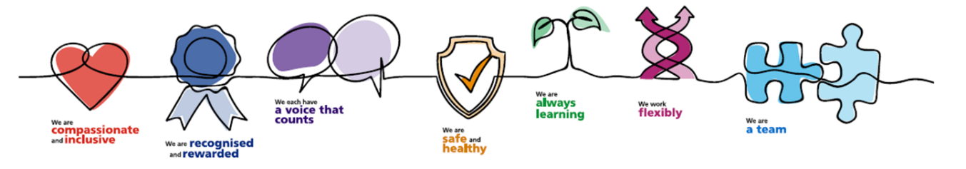
In 2021 Solent scored amongst the best performing trusts of our type in 3 out of 9 themes, those being:
- We are compassionate and inclusive
- We each have a voice that counts
- Staff Engagement

However, Solent this year has now ranked top for 5 of the 9 key metrics, an improvement from 3 last year.

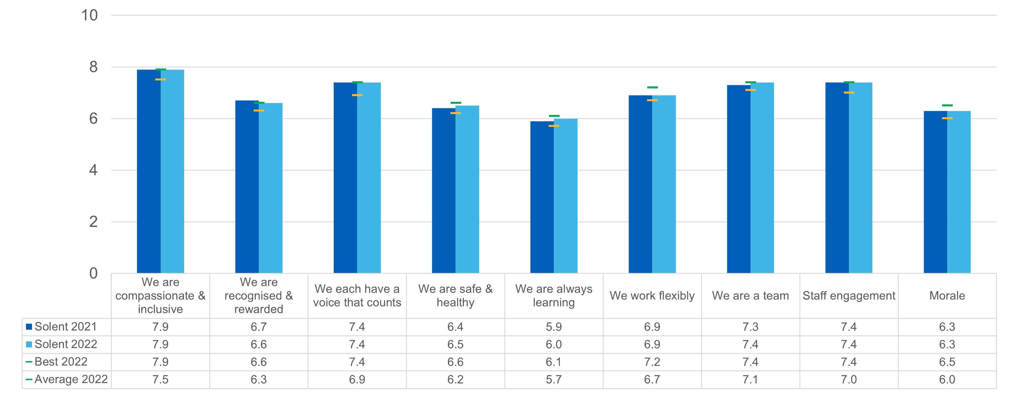

Research shows that if we make improvements on race equality, we will make advances on all nine protected characteristics.
Therefore, we have used the Workforce Race Equality Standard (WRES) methodology at Solent with the aim of improving on the following as part of our commitment to the 10-year WRES plan:
- Increase our talent pool of BAME staff
- Ensure there is an equitable process for BAME staff in relation to Disciplinary and Grievance
- Improve our understanding on blind‐spots in the recruitment process

We have also worked to use the Workforce Disability Equality Standard (WDES) with the view to ensuring our commitment to improving diversity, inclusion and belonging.

For the first time this year 2 new metric frameworks have been introduced.

- BANK Only Workers WRES

- There are an estimated over 150,000 bank-only workers in NHS trusts.
- Bank WRES has been designed to support NHS England’s strategic aim of improving the quality of bank provision as a flexible option for staff.
- The WRES team have developed a set of indicators for NHS bank only workers, designed to explore the experiences of this group, the indicators are aligned to the People Promise and People Plan.
- There are nine indicators for the bank-only workers WRES. The indicators will measure the following:
  - Representation by ethnicity and gender
  - Experience in the workplace, including disciplinaries, dismissals, bullying and harassment
  - Route of entry into the NHS.
to read more about the WRES indicators for the NHS bank only workforce click here

- Medical WRES
- The Medical Workforce Race Equality Standard (MWRES) was launched in 2020 to analyse national race equality for medical and dental workforce.
- The Medical Workforce Race Equality Standard (MWRES): the first five sets out practical actions based on data and evidence to tackle existing inequalities in the medical workforce.
- It is jointly developed alongside royal medical colleges, regulators and key stakeholders.
- The 2020 MWRES report found that BME doctors are:
  - Underrepresented in Consultant posts
  - Underrepresented in academic and leadership positions
  - Less likely to progress through postgraduate exams and Annual Review of Competency Progression
  - More likely to experience discrimination, harassment, bullying and abuse from patients and other staff.
- MWRES compliments the work of WRES in evidencing NHS compliance with the Public Sector Equality Duty (EqA2010) to advance race equality for the dental and medical professional groups.
- MWRES data and analysis is used to inform actions to advance race equality and develop targeted interventions to address structural and organisational disparities that result from race.
- MWRES data will help providers to develop tailored programmes for BME staff to break down barriers to advancement and improve experience in general.
to read more about MWRES click here

Solents Community

We aim to ensure that our community partners reflect our diverse communities in areas we work in and have been involved in creating the Alongside Communities Strategy.
We intend to continue to improve our data collection by offering support through our learning and development team with self‐identification and refreshing data for our workforce and patients.

The Venn diagram below outlines the connection and collaboration of the Community engagement and experience and the EDIB Team in Solent.

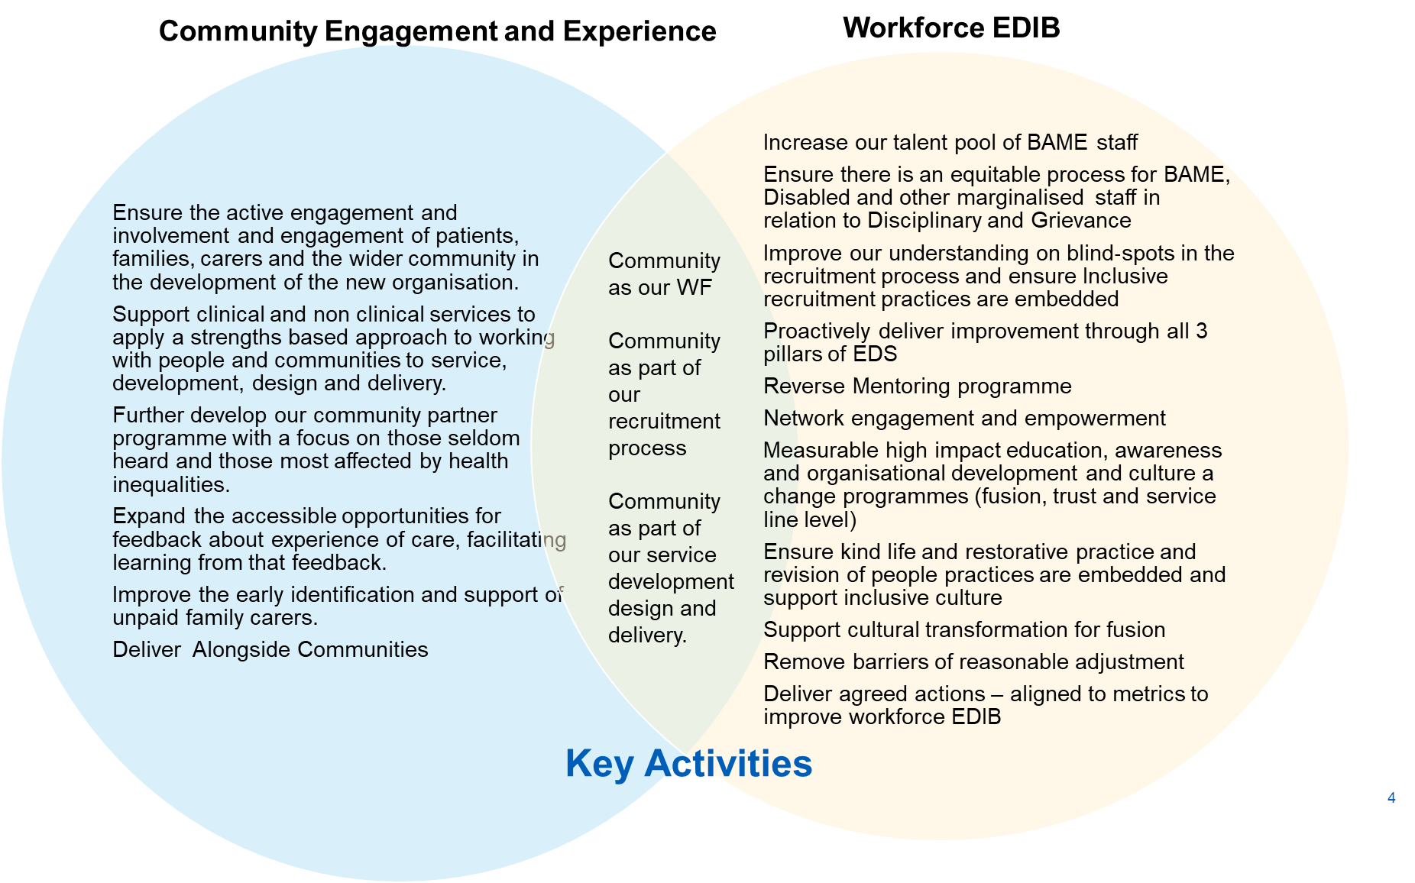

See appendix for Solent Community Engagement Annual Report

Delivering on Standards for Equality Diversity, Inclusion and Belonging

NHS Standards ‐ EDS3 Pilot Progress

Solent NHS Trust provides services across richly diverse communities, and this should influence how we provide our services as well as how we treat our staff, both current and future.

All NHS organisations are encouraged to use the EDS (Equality Delivery System). The Equality Delivery System (EDS) was officially launched in 2011, and updated in 2013, with the aim of embedding equality within the current and future NHS – for both commissioner and provider organisations. It is an improvement tool for patients, staff, and leaders of the NHS.

In order to maximise the opportunities that EDS can offer, organisations are encouraged to engage in active conversations with people who use services, patients, public, staff, staff networks, community groups and trade unions to review and develop their approach in addressing health inequalities.

The tool is split into three domains, all driven by data, evidence, engagement, and insight.

- Domain 1: Commissioned or provided services
- Domain 2: Workforce health and well-being
- Domain 3: Inclusive leadership

Implementation of the Equality Delivery System (EDS) is a requirement of both NHS commissioners and NHS providers. It can support compliance with the Public Sector Equality Duty (PSED) and will increase the profile and consideration being given to equality within organisational and governance processes.

Each outcome is scored based on the evidence provided. Once each outcome has a score, they are added together to gain domain ratings. Domain scores are then added together to provide the overall score, or the EDS Organisation Rating. Solent NHS Trust working with staff and the people who use our services assess their position against the standards and use that to help set improvement aims for the future
The scoring system allows organisations to identify gaps and areas requiring action

Undeveloped activity – organisations score 0 for each outcome | Those who score under 8, adding all outcome scores in all domains, are rated Undeveloped
Developing activity – organisations score 1 for each outcome | Those who score between 8 and 21, adding all outcome scores in all domains, are rated Developing
Achieving activity – organisations score 2 for each outcome | Those who score between 22 and 32, adding all outcome scores in all domains, are rated Achieving
Excelling activity – organisations score 3 for each outcome | Those who score 33, adding all outcome scores in all domains, are rated Excelling

Summary Conclusion – See appendix for full report and action plan

Domain | Outcome | Score
Domain 1: Commissioned or provided services | 1A: Patients (service users) have required levels of access to the service | 1
 | 1B: Individual patients (service users) health needs are met | 1
 | 1C: When patients (service users) use the service, they are free from harm | 2
 | 1D: Patients (service users) report positive experiences of the service | 2
Domain 2:  Workforce health and well-being | 2A: When at work, staff are provided with support to manage obesity, diabetes, asthma, COPD, and mental health conditions | 2
 | 2B: When at work, staff are free from abuse, harassment, bullying and physical violence from any source | 1
 | 2C: Staff have access to independent support and advice when suffering from stress, abuse, bullying harassment, and physical violence from any source | 2
 | 2D: Staff recommend the organisation as a place to work and receive treatment | 3
Domain 3:  Inclusive leadership | 3A: Board members, system leaders (Band 9 and VSM) and those with line management responsibilities routinely demonstrate their understanding of, and commitment to, equality and health inequalities | 3
 | 3B: Board/Committee papers (including minutes) identify equality and health inequalities related impacts and risks and how they will be mitigated and managed | 3
 | 3C: Board members and system leaders (Band 9 and VSM) ensure levers are in place to manage performance and monitor progress with staff and patients | 2
Overall Score for Solent NHS Trust | Achieving Activity | 22

As a result of completing the EDS review an action plan for 23/24 with objectives was co-created and the following areas of improvement identified (for full detail see appendix)

- Objectives for Domain 1: Commissioned or provided services
  - To better understand the differing levels of access for different demographic groups and to ensure services are targeted on this basis to and promote inclusion and improve under representation.
  - Service line leads will carry out further stakeholder mapping and engagement activities with diverse communities to ensure health needs are understood and met through service design and provision.
  - To ensure that Co-production continues in a sustained way to support the development and delivery of services.
  - To improve the way we collect and use data to ensure that feedback is effectively collected, and that patient feedback is reviewed through an equality and diversity lens to ensure that underrepresented groups are being treated equitably.

- Domain 2: Workforce health and well-being
  - To understand the extent to which different groups of people access health offers, particularly where prevalence of certain health conditions is higher and to use this information to proactively address any inequalities identified.
  - To support staff who experience harassment and improve accessibility to appropriate specialist support and advice.
  - To improve the reach of access to mental health services for all staff groups
  - To continue to raise awareness of specialist support e.g., Musculoskeletal/physiotherapy access, menopause 1-1 support, Employee Disability and Neurodiversity Advice service (EDNA)

- Domain 3: Inclusive leadership
  - To further develop the role modelling and voice of senior leaders and increase activated allyship
  - To further develop the role modelling and voice of senior leaders and increase activated allyship
  - Further engagement and ownership EDIB Plan and People Strategy- so to ensure that actions are owned and acted on at service line level

NHSE Workforce Race Equality Standard (WRES)

Evidence shows that a motivated and inclusive workforce results in better patient care and increased patient satisfaction and safety. The Workforce Race Equality Standard (WRES) is a set of 9 indicators that are used to measure workforce race equality and has been mandated through the NHS standard contract since 2015‐16. The metrics for indicators 1 – 4 are taken from ESR data, 5 – 8 from the NHS staff survey results and metric 9 from Trust Board.
All workforce data has been taken from the ESR records dated 1st April 2021 to 31st March 2022. This data is then fed into the WRES report for 2020. The data covers staff categorised under the Agenda for Change. Please note that the WRES team only ask for data on substantive staff.
In 2023 there were 4,430 members of substantive staff, of which 12.8% (10.7% on 31/3/22) were from a Black Asian Minority Ethnic background. The 2021 Census data shows that there are 1,400,899 residents in total of which 186,090 are from BAME background – this equates to circa 13%, therefore illustrating good representation at board level.

Board Representation
As of reporting of 31st March 2023 - 23% of the board are from BAME backgrounds
WRES Category | Headcount | Headcount % | Board Headcount | Board Headcount %
BME | 569 | 12.84% | 3 | 23.08%
White | 3810 | 86.00% | 10 | 76.92%
Z Not Stated/Not Given | 51 | 1.15% | 0 | 0.00

Across our total workforce we are broadly representative of the population we serve, with 12.8% of colleagues from Black Asian minority ethnic backgrounds versus 13.00% of the Hampshire population.

Colleagues from Black Asian minority ethnic groups makeup 2/3 of our Board Level Directors.
Our Diversity inclusion plan aims to address this inequality and under representation throughout all bandings.

Over a 1/3 of the consultants and non-consultant are from BAME background and over a ¼ medical dental trainees.

There is however unrepresented in bands 3-9 (given latest census data shows approx. 13% BAME)

There is also an under-representation of colleagues in band 4 with only 3.2 % of colleagues in this band of Black Asian minority background. However, there was an increase in band 5 indicating internal promotion.

It is only grade band 2 where BAME are over-represented and in all medical and dental grades.
 |  | Headcount (%)
Clinical / Non-Clinical | WRES Banding | BME | White | Z Not Stated/Not Given
Clinical | Band 2 | 18.3% | 81.1% | 0.6%
 | Band 3 | 7.5% | 91.8% | 0.7%
 | Band 4 | 10.8% | 88.4% | 0.8%
 | Band 5 | 23.5% | 74.3% | 2.2%
 | Band 6 | 10.5% | 89.0% | 0.5%
 | Band 7 | 6.9% | 92.8% | 0.4%
 | Band 8a | 6.4% | 91.3% | 2.3%
 | Band 8b | 13.6% | 86.4% | 0.0%
 | Band 8c | 7.1% | 92.9% | 0.0%
 | Band 8d | 11.1% | 88.9% | 0.0%
 | Band 9 | 0.0% | 100.0% | 0.0%
 | Medical & Dental Consultant | 36.4% | 60.6% | 3.0%
 | Medical & Dental Non-Consultant Career Grade | 34.0% | 60.8% | 5.2%
 | Medical & Dental Trainee Grades | 26.5% | 64.7% | 8.8%
Non Clinical | Band 2 | 23.5% | 75.5% | 1.0%
 | Band 3 | 6.3% | 93.7% | 0.0%
 | Band 4 | 3.2% | 92.1% | 4.8%
 | Band 5 | 12.2% | 86.6% | 1.2%
 | Band 6 | 3.6% | 94.6% | 1.8%
 | Band 7 | 7.2% | 92.8% | 0.0%
 | Band 8a | 4.3% | 91.5% | 4.3%
 | Band 8b | 9.5% | 90.5% | 0.0%
 | Band 8c | 4.2% | 95.8% | 0.0%
 | Band 8d | 0.0% | 100.0% | 0.0%
 | Band 9 | 0% | 100% | 0.0%
 | Director | 66.7% | 33.3% | 0.0%
Table - Breakdown of staff banding and ethnicity

Work themes in place to address these issues include (please see full action plan for further detail):

- Reverse Mentorship for Inclusion Programme
- Sharing job opportunities with Community Partners
- Overhaul and debiasing of our attraction and recruitment practices
- Working with specific workstreams across HIOW ICS (Hampshire Isle of Wight Integrated Care System) focusing on recruitment, retention, and talent management and Leadership development
- Anti‐Discrimination Taskforce and introduction of a 2steps hate crime reporting system
- Education, awareness and allyship programs
- Greater engagement with the networks in co creating new people policies and practices that are free from bias

Where we have seen improvement:

1 | Percentage of BAME staff  Target: Increase by 2% (total 11.3%) by July 2022. |  |  | Revised target for Sept 23  In line with local census data
2019/20  9.2% |  | 2020/21  9.3% | 2021/22  10.7% |  | 2022/23  12.8%
9. | BAME board membership - Percentage difference between the Board’s voting membership and its overall workforce  Target: Increase diversity of board membership when vacancies arise. |  |  | Revised target for Sept 23 TBC
2019/20  15.4% BAME Board members  18.2% Voting BAME Board members |  | 2020/21  21.4% BAME Board members  18.2% Voting BAME Board members | 2021/22  16.7% BAME Board members  20.0% Voting BAME Board members | 23%  22%

- The BAME network is a safe space for people to share their experiences and learn from others. Ongoing promotion of Freedom to Speak Up for BAME staff continues, which enable staff the opportunity to raise concerns in a confidential and safe environment.
- Board diversity is important to avoid group think, and it allows more nuanced discussions that will reflect the colleagues that work for Solent and the communities we serve.

From our staff survey results published in March 2022 we can see that staff satisfaction levels are comparable across both white and BAMA staff. Two exceptions are BAME staff rating the trust higher for both ‘we are always learning’ and ‘staff engagement’ – recognition for all the great work done by the trust over the last year.

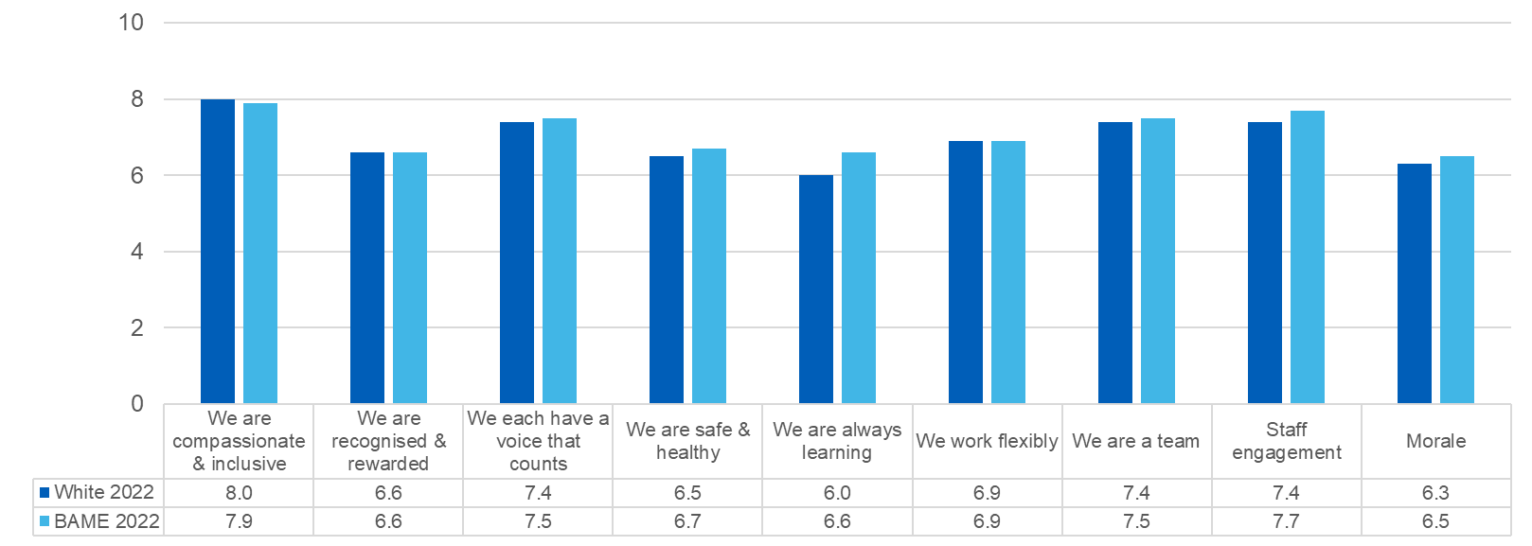

Where we need to improve
Relative likelihood of white applicants being appointed from shortlisting across all posts compared to BAME applicants  Target: decreased to 1.2 by July 2022 |  |  | Revised target for Sept 23  1.2
2019/20  1.40 | 2020/21  1.36 | 2021/22  1.41 | 2022/23  1.43

- There is ongoing work to ensure our attraction and recruitment process are free from bias. It is worthwhile to note, that there is a better % better at Offer – at offer there is a ratio of 1.27.

- An action plan is underway and the following improvements are being made to ensure positive action and improvement is made to the recruitment process this includes, adding a new and stronger equality statement on the recruitment site and all job adverts, the design of a training package to develop a bank of recruitment allies that will include community partners as well as colleagues from across the workforce and that will be on all band 7 and above interview panels and a clear and transparent escalation route for recruitment allies to raise concerns, closer monitoring and follow up to ensure compliance of the two ticks and disability confident and armed forces covenant.

- However less BAME offers convert to appointments - 30% of those BAME offered do not become appointed, vs 22% White. This drop off is due to Right To Work checks being carried out after offer – also worth noting there was a large scale NHSE event that recruited and offered but high % did not translate into new starters and this impacted on conversion rate and lowered due to RTW.

- It’s worth considering the impact of the recent HCSA visa that came out last years that enables overseas on sponsorship for visa. This will also have impacted on recruitment stats. More people will have applied and been SL and offered but the reality is the NHS does not financially sign off recruitment of internationally recruited HCAs.

Percentage of staff experiencing harassment, bullying or abuse from staff in last 12 months  Target: Decrease percentage to below 15% by July 2022. |  |  | Revised target for Sept 23  -15%
2019/20  18.2% | 2020/21  18.1% | 2021/22  16.4%. | 2022/23  16.7%
- We have seen an increased response rate from 214 to 246 with this indicator and we have also seen a marginal increase in the number of staff experiencing harassment, bullying or abuse from staff in last 12 months – an increase of 0.3%. The median benchmark average for this indicator is 22.8% and has remined stable for past 2 years.

- This year’s EDIB action plan includes the introduction of the Kind Life model – an evidenced based approach that reduces bullying and harassment and supports early restorative resolution when conflict does arise

Percentage of staff believing that trust provides equal opportunities for career progression or promotion  NB the data collection and calculation formula have been changed by the national team, to now includes ‘don’t know’ in the base – new figure in brackets for 2019/2020.  Target: Increase percentage to 85% by July 2022. Revised target – proportional increase – 60% |  |  | Revised target for Sept 23  +60%
2019/20  82.4% (47.9%) | 2020/21  80.3% (56.1%) | 2021/22  57.7% | 2022 /23  56.9%

- This is an area that continues to be a recognised challenge and have lunched the reverse mentoring programme with the aim to address this further.

- The national benchmark average is currently 49.6% but it is clear through this data and staff voice in the networks further needs to be actioned to address the inequalities here.

- This will remain a clear priority and focus in this year’s EDIB action plan.

- Percentage of staff personally experiencing discrimination at work from a manager/team leader or other colleagues  - Target: Decrease percentage to below 10% by June 2022. |  |  | - Revised target for Sept 23 TBC  - -10%
- 2019/20  - 9.5% | - 2020/21  - 13.8% | - 2021/22  - 9.6% | - 2022/23  - 10.2%
- The national average this year is benchmarked by comparison at 13.6%.

- In Solent there has been an increase or 0.6% for ethnic minority colleagues experiencing discrimination at work from manager / team leader or other colleagues in the last 12 months.

- The response rate for this indicator has gone from 219 to 246, an increase of 27.

- A spotlight needs to remain on this to ensure that this does not continue to climb and a deeper look by People Partners needs to consider service line data so that targeted interventions can be put in place.

NHS Workforce Disability Equality Standard (WDES)

The WDES are a set of ten specific metrics that compare the workplace experience of staff with a disability and non‐disabled staff. It allows the Trust to understand the experiences of their staff with a disability and plan to create a more inclusive work environment. As with the WRES the metrics are taken from both ESR and staff survey results.
All workforce data has been taken from the ESR records dated 1st April 2022 to 31st March 2023. Please note that the WDES team only ask for data on substantive staff.
In 2023 there were 4,430 members of substantive staff, of which 4.4% had a known disability. We have seen an increase in colleagues declaring their disability from 81.3% in 2022 to 83.8% in 2023. However there remains 16% undeclared in ESR.
By comparison of the staff survey returns there appears to be 19% discrepancy ratio – with a much higher declared disability rate, indicating that many colleagues will only declare through the anonymity of the staff survey.

This data is being collected as part of the 2023 data collection for the Workforce Disability Equality Standard (WDES). The aim of WDES is to improve the working and career experiences of Disabled staff in the NHS. The WDES is mandated through the NHS Standard Contract and has been approved as a data collection by the NHSX Data Alliance Partnership. It has also been subject to a data protection impact assessment.

This year’s survey suggests we have work to do in meeting the needs of staff with disabilities. Staff with disability rates Solent lower for all 9 measures, with the biggest discrepancy for ‘we are safe and healthy’. This is driven by dissatisfaction with both burnout and negative experience with the trust.

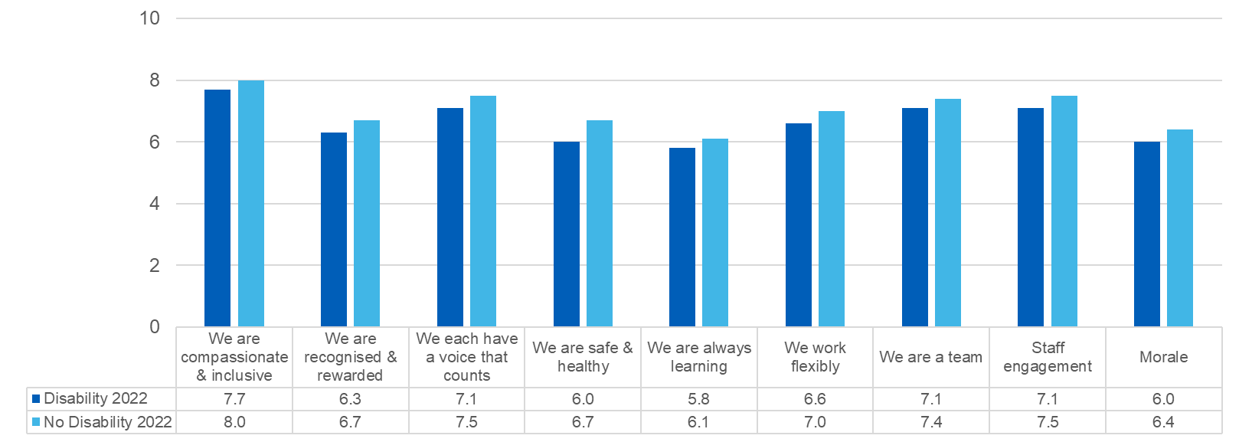

Below is an infographic that shows the results of the WDES
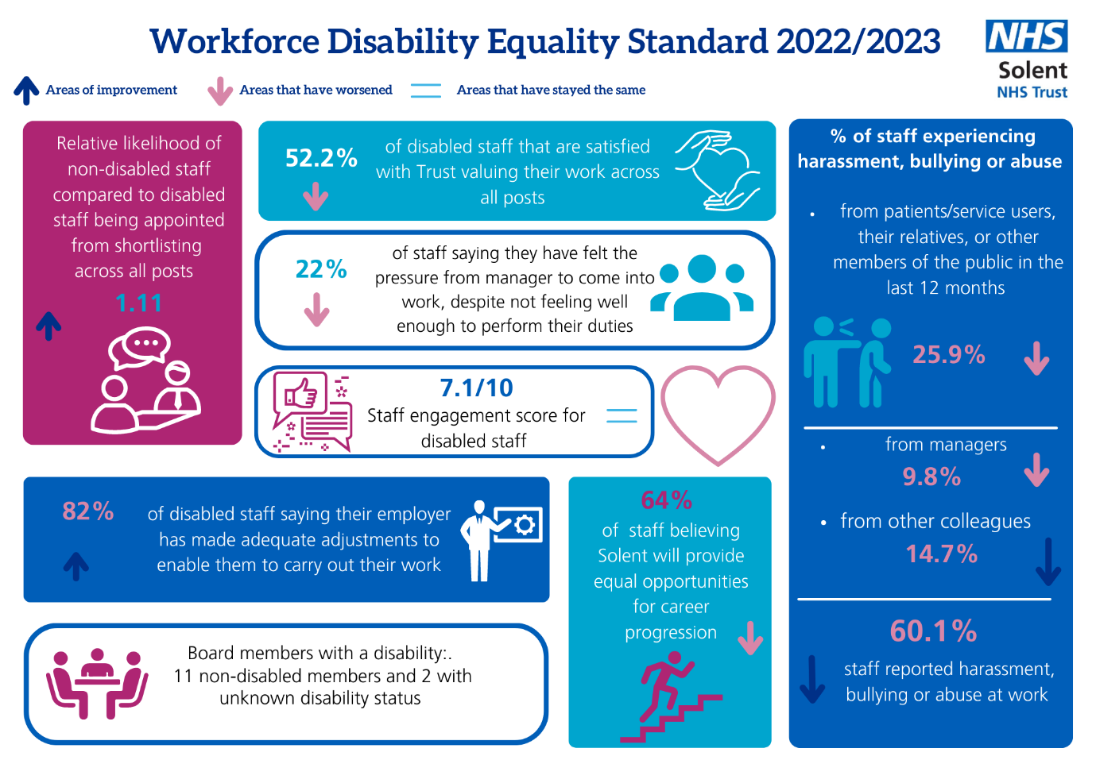

Where we have seen improvement

- The percentage of staff in AfC pay bands or medical and dental subgroups and very senior managers (including Executive Board members) compared with the percentage of staff in the overall workforce.  - Target  - Increase disability declaration rates on ESR across Solent to 60% by July 2022 – revised target 90%  - Increase the number of staff with a disability in bands 8a or above to 4% |  |  | - Revised target for Sept 23  - +90%  - +4%
- 2019  - Unknown | - 2020  - Disability status not declared 20.64% | - 2021  - Disability status not declared 18.7% (81.3% declared)  - 524 staff in 8A or above out of those 15 are disable= 2.8%  - n.b 3.9% of total WF have a disability | - 2022/23  - 16.2% (83.7% declared)  - 570 of which 20 = 3.5%  - 4.4% of total WF
- Engagement work was undertaken with the network to encourage declaring and understanding the barriers to declaring – this has had a positive impact. However, there is further work that is being undertaken to ensure greater psychological safety around declaring disability as well as better and more inclusive leadership and management support and process being in place. When we compared responses (in April 23) of staff survey replies to that declared on ESR there showed to be 18% disparity ratio

- It is worth while noting that national NHS ESR categories (employee records) are outdated in language and do not effectively cover the range of disabilities, therefore it is difficult for staff to change their declaration if they can’t see themselves represented in the categories available.

Relative likelihood of non-disabled staff compared to Disabled staff being appointed from shortlisting across all posts  Target:  - Equal likelihood of non-disabled staff being appointed from shortlisting across all posts |  |  | Revised target for Sept 23  1
2019  1.20 | 2020  1.06 | 2021  1.28 (It is possible the 2020 the anomaly) | 1.11
- There has been a small positive shift here and the introduction of a new system has helped to support debiasing

- There is further improvement requited here and there will be a number of actions in this year EDIV plan to ensure greater inclusivity in Solents approach to attraction, assessment and selection

- Percentage of staff experiencing harassment, bullying or abuse from patients/service users, their relatives, or other members of the public in the last 12 months  - Target: Decrease percentage to below 25%  - Percentage of staff experiencing harassment, bullying or abuse from managers in the last 12 months  - Target: Decrease percentage to below 10%  - Percentage of staff experiencing harassment, bullying or abuse from other colleagues in the last 12 months  - Target: Decrease percentage to below 12% |  |  | Revised target for Sept 23 TBC  - Below 25%  - Below 10%  - Below 12%
2019  - 29.1%  - 12.6%  - 15.8% | 2020  - 27.2%  - 13.9%  - 16.7% | 2021  - 25.8%  - 9.2%  - 15.9% | 2022/23  - 25.9%  - 9.8%  - 14.7%

- We have had an increased response to this indicator from 589 to 649 colleagues with LT health condition and or disability.

- This is in line with the national median benchmark in so far as the trend has remained stable – we are significantly above the national benchmark average that currently is 32.0%

- We currently sit above the national benchmark, that indicates 12.3% of staff experiencing harassment, bullying or abuse from managers in the last 12 months – however the small increase here indicates that more work is be done with raising awareness – this remains a people priority for Solent. This year we have procured bespoke manager sessions with SimComm academy, and neurodiversity elearning for managers and colleagues from Lexxic, there is additional manager information to be coming from Genius Within.

- A strong improvement of 1.2% from 15.9% to 14.6% staff experiencing harassment, bullying or abuse from other colleagues in the last 12 months – the national benchmark currently at 18.9%. This year we are introducing a new respectful resolution framework and training that will address and support to build a kinder culture and reduce micro aggressions

Percentage of disabled staff saying that their employer has made adequate adjustment(s) to enable them to carry out their work  Target: Increase percentage to over 90% by July 2022 |  |  | Revised target for Sept 23 TBC
2019  83.3% | 2020  86.4% | 2021  81.2% | 2022/23  82.0%
- This remains a priority as part of the people strategy and the EDIB plan –the national average for this is 78.8%

- This is an area that remains a priority for this year – A comprehensive reasonable adjustments guidance and provision menu is to be rolled out which will be used to improve our performance in this area.

- This is informed by staff voice and an engagement activity that has been lead and coordinated through the Disability network. The EDNA (that stemmed from the network) currently has a 13-week waiting and business case being written to extend service to meet demand.
- Education and support for our Managers, People Partners and Occupational Health will be arranged where they can further gain insight and learn from the lived experience.

Where we need to improve
Further work to improve our people polices and practices are required for this year – specifically capability and absence policies.Further education of managers and colleagues around supporting disability and neuro diversity in the workplace is required and ongoing and the voice of lived experience embedded in to policy and practice review.

 | Percentage of staff saying that the last time they experienced harassment, bullying or abuse at work, they or a colleague reported it in the last 12 months  Target: Increase percentage to 75% by |  | Revised target for Sept 23 TBC  + 75%
2019  59.7% | 2020  58% | 2021  65.3%  This is a notable increase and also goes against the benchmark trend which is pretty stable. | 2022/23  60.1%
- A decrease of 5.2% of colleagues who reported harassment bullying or abuse at work – albeit in line with national benchmark.

- The staff survey results, specifically the ‘we are safe and healthy’ domain show that our colleagues are feeling less psychologically safe to raise these issues due to attitudes and behaviors of our colleagues and managers who are often the source of the issue in the first instance. This will need to remain a priority in this this year’s EDIB plan to ensure colleagues feel safe to speak up.

6 | Percentage of staff saying that they have felt pressure from their manager to come to work, despite not feeling well enough to perform their duties  Target: Decrease percentage to below 20% |  | Revised target for Sept 23 TBC
2019  27.8% | 2020  25.9% | 2021  20.3% | 2022/23  22.0%
- We are below the national average of 18.9% with regards to this indicator and that is trending in a positive direction. Given that in Solent this is increased and gone against national trend further investigation is needed to ensure appropriate action can be embedded in to the EDIB action plan to address this.

- We are currently reviewing the absence management people practise framework to ensure a more inclusive approach – this return only furthers strengthens the need for this piece of work and for co creation of this with colleagues with lived experience.

- We are also rolling out a reasonable adjustment framework and reviewing the way these adjustments are funded so that managers can access a central fund.

- The DisAbilty Network have been and will be continue to be, key to ensuring staff voice comes through around this metric and with raising awareness around the health and wellbeing of colleagues with disability and long term health condition

Disability in the Workforce

Solent NHS Trust’s workforce is made up of 4.4 % of staff with a known disability, although there has been a drop from 18.7% in 2022 to 16.2% that have not declared their status.

There is clearly a need to encourage more people declaring their disability status, particularly amongst the medical and dental community. Only 1.5% declared with disability, 46% not stated.

In the non-clinical workforce there is under-representation in bands 2-5.
 |  | Headcount (%)
Clinical / Non-Clinical | WDES Banding | Disability | No Disability | Unknown
Clinical | Band 2 | 4.3% | 80.5% | 15.2%
 | Band 3 | 4.2% | 83.8% | 12.0%
 | Band 4 | 6.3% | 80.2% | 13.5%
 | Band 5 | 4.1% | 84.2% | 11.7%
 | Band 6 | 5.5% | 81.3% | 13.2%
 | Band 7 | 5.0% | 77.9% | 17.1%
 | Band 8a | 5.2% | 73.4% | 21.4%
 | Band 8b | 2.3% | 79.5% | 18.2%
 | Band 8c | 3.6% | 60.7% | 35.7%
 | Band 8d | 11.1% | 77.8% | 11.1%
 | Band 9 | 0.0% | 80.0% | 20.0%
 | Medical & Dental Consultant | 1.5% | 42.4% | 56.1%
 | Medical & Dental Non-Consultant Career Grade | 2.1% | 67.0% | 30.9%
 | Medical & Dental Trainee Grades | 0.0% | 29.4% | 70.6%
Non Clinical | Band 2 | 1.5% | 74.5% | 24.0%
 | Band 3 | 3.6% | 80.2% | 16.2%
 | Band 4 | 1.6% | 76.2% | 22.2%
 | Band 5 | 2.4% | 86.6% | 11.0%
 | Band 6 | 5.4% | 75.0% | 19.6%
 | Band 7 | 5.8% | 79.7% | 14.5%
 | Band 8a | 4.3% | 83.0% | 12.8%
 | Band 8b | 4.8% | 76.2% | 19.0%
 | Band 8c | 8.3% | 87.5% | 4.2%
 | Band 8d | 0.0% | 76.9% | 23.1%
 | Band 9 | 0.0% | 83.3% | 16.7%
 | Director | 0.0% | 100.0% | 0.0%
Table - Breakdown of staff banding and disability

Actions that have been taken to improve the work experience of staff with a disability and long-term health condition include:
- Reverse Mentorship for Inclusion Programme being developed
- Anti‐discrimination Taskforce and the implementation of a 2-step hate crime reporting system
- Solents Disabilities Awareness Day Conference
- Managers training and guidance
- Lunch of Employment Disablity Neurodiversity Advice Service
- Neuro Diversity eLearning
- Coaching for neuro divergent colleagues
- Refreshed Terms of reference and Executive sponsorship
- Delayered accountability and assurance framework that supports actions and outcomes and empowers staff voice
- Creation of Reasonable adjustments Framework and transparent funding process
- Accessibility audits for our Solent Sites
- Planned and well-advertised events
- Inclusion of lived experience representation in case review of People Cases/ Employee Relations cases

Analysing Diversity & Inclusion Workforce Data at Solent NHS Trust

The following staff data is as of 31 March 2023 where the total number of substantive staff was 4,430 and provides a snapshot of our staff. Data below is for substantive staff only.

Occupations by Ethnicity
Ethnicity | % Workforce
BAME | 12.8%
White | 86.0%
Not Stated | 1.2%
Table Ethnicity of staff

A deep dive into recruitment has been carried out to ensure that Solent is truly inclusive in its recruitment, and subsequent action plan developed. A working group has been established to now take the findings along with national guidance to change the way attract, assess and select.

Solent are also working with colleagues across the ICS to address recruitment and retention of BAME staff, as well as focusing on a service line level.

Workstream 1 of the diversity and inclusion plan aims to:
Re – design the attraction, recruitment and onboarding process to increase diversity and improve inclusion

Key Success indicators outputs and outcomes will be:
- Working with community partners to access underrepresented communities
- Working with Networks for co-production
- Redesigning Job adverts and JDs
- Implementing Oleeo system
- Redesign of assessment process
- Development and implementation of a diverse Bank of Inclusion Ambassadors *(LH)
- Implementation of comply and explain
- Increase of shortlisted and successful applicants from diverse back grounds
- Train the trainer scalable inclusive recruitment workshop to embedded new ways of working / recruitment
- Improved more accessible volunteering pathways to recruitment (Community Engagement)
- Positive impact on WRES, WDES, MWRES indictors

Age of workforce

Age | % Workforce  2022 | % Workforce  2023
<=20 Years | 1.6% | 0.7%
21-25 | 6.2% | 5.9%
26-30 | 9.5% | 10.5%
31-35 | 12.9% | 13.7%
36-40 | 11.7% | 12.8%
41-45 | 11.8% | 12.6%
46-50 | 12.0% | 11.6%
51-55 | 12.6% | 12.6%
56-60 | 11.8% | 11.3%
61-65 | 7.7% | 6.4%
66-70 | 1.5% | 1.3%
>=71 Years | 0.8% | 0.6%
Table Age of workforce

There has been a decrease at both ends of the age profile indicating a more centrally distributed age profile. However there has been an increase in headcount across the whole WF and this has impacted on the %. There has been an increase headcount in the range 26-55 of 308, indicating a stable age range. The
largest loss of headcount is 42 in the age range 61- 64.

In the age 26- 60 we have increased from 82.3% to 85.2% and the age range 26- 55 we have 70.5% to 73.9%. Increase the central age range of 3.4% increase across 26- 55, as such we have a younger work force that we did a year ago – under 60s have increased by 2.7%

There remains a large proportion of our staff working for the Trust are aged between 51- 60. The Trust has over the past year put plans in place to support an ageing workforce. There has been a successful for first year for the 50+ Staff Network.

This network is a proactive space for connection, support, advocacy, action and education for staff aged 50+. They meet regularly throughout the year and collaborate to explore issues that have been raised and that are important to our colleagues. They are about inspiring change and making sure our Trust is age inclusive, with a focus on health and wellbeing, addressing inequalities and challenging stigma.

This network has newly formed and has started to make enquiries around how best to support people nearing retirement to work out the financial impact of stepping down.

The lowest age group that is represented is those who are aged 71 or over and for those aged 20 or younger.

Sexual Orientation Monitoring - SOM

Sexual Orientation | % Workforce  2022 | %  Workforce 2023
Heterosexual or straight | 79.3% | 80.5%
Bisexual | 1.3% | 1.8%
Gay or Lesbian | 1.6% | 1.7%
Undecided | Not recorded | 0.1%
Other sexual orientation not listed | Not recorded | 0.2%
Other/Not stated (person asked but declined to provide a response) | 17.7% | 15.7%
Table Sexuality of workforce

The LGBTQ+ Staff Network provides a space for LGBT+ staff and allies to come together and talk, share and connect with each other in a safe and positive environment. The network promotes a working environment where all LGBTQ+ staff feel supported, valued and able to be themselves without fear of prejudice. They also enable staff to achieve their potential, challenge discrimination and positively promote equality and acceptance.

The data indicates that a significant proportion of the workforce have not provided an answer to this question. The reasons for this are, of course, multifaceted, but we need to ensure that our staff are not leaving this question unanswered because they fear discrimination.

In response to a Stonewall’s Workplace Equality Index for 2021/22, which identified some gaps in how the Trust is supporting the Lesbian, Gay, Bisexual, Transexual Plus (LGBT+) community in the Trust, we developed an action plan covering eight core areas.

These were:
- Policies and benefits
- The employee life cycle
- The LGBT+ Staff Network
- Empowering individuals
- Leadership
- Monitoring
- Supply chains
- External Feedback

Work to date to address improvement in these areas included:

- A new Trans Inclusion Policy that explicitly clarifies the Trust’s commitment to trans and non-binary staff
- Consistency of policies to avoid confusion and to provide clarity of access to all employees, including LGBTQ+ community, on benefits such as those contained in the Family and Leave
- Support of the new/updated policies by the LGBTQ+ Staff Network
- Public facing policy that explicitly bans biphobic, homophobic and transphobic discrimination in your services written and implemented
- Wider publicity/promotion of new policies
- Staff provided with training around homophobia, transphobia and biphobia; advice on how staff can challenge and report such incidences
- Providing opportunities for all non-LGBT employees to become LGBTQ+ allies to embed LGBT inclusion across the organisation.
- Wider use of the rainbow badge to be promoted and take up documented

Work that is ongoing and still required is:

- Roles flighted on LGBTQ+ inclusive website and diversity fairs
- Share info on LGBTQ+ Staff Network on NHS Jobs and Oleeo
- Recruiting managers are provided with ‘inclusive’ training
- LGBTQ+ awareness days/events are promoted and well attended. The network will hold a minimum of four events, open to members and allies, each financial year.
- Revised TOR to show how the network provides confidential support to all employees on LGBT issues a
- TOR to provide clarity on how staff report biphobic, homophobic or transphobic bullying and harassment incidents
- Implementation of a formal mechanism, by the LGBTQ+ network, for bi and trans issues to be engaged with, promoting itself as inclusive of all LGBTQ+ identities, including those with multiple marginalisations
- Introduction of specific spaces (safe spaces) for underrepresented LGBT groups to encourage people to share experiences
- Engagement events for LGBTQ+ community within the Trust to provide even more opportunities to hear from those who seldom speak at/attend meetings
- Reporting/escalation e.g., to People Committee of issues raised by LGBT Staff Network
- Exploring change of ESR and other work systems to use the term ‘bi’ as an umbrella term instead of ‘bisexual’ when collecting protected characteristics data/monitoring questionnaires
- Adding ‘I use another term’ as a free text option so that all LGBTQ+ staff can correctly identify themselves

Occupation by Gender

Gender | % Workforce
Female | 85.9%
Male | 14.1%
Table Gender of workforce

Solent has a predominantly female workforce, and this has also been highlighted in the Gender Pay Gap report. However, currently the national ESR (Electronic System Recording) system only allows individuals to categorise themselves as male or female and there is no option for non‐binary staff. This is something that needs to be addressed at a wider level and raised through the HIOW.

Disability

Disability | % Workforce 2022 | % Workforce  2023
Yes | 3.9% | 4.4%
No | 77.3% | 79.3%
Not stated | 18.7% | 16.2%
Table Disabled and non‐disabled staff

Type of Disability | % Disabled Workforce  2022 | % Disabled Workforce  2023
Unspecified | 40.3% | 48.2%
Learning disability/difficulty | 22.8% | 16.2%
Long standing illness | 15.7% | 11.7%
Physical impairment | 9.9% | 9.6%
Sensory impairment | 5.3% | 5.6%
Mental health condition | 4.3% | 6.1%
Other | 1.8% | 2.5%
Table Type of Disability disclosed

A large proportion of staff have not answered this question. Solent are committed to ensuring that staff with a disability are supported and that staff feel able to declare their disability without fear of judgement or discrimination. As previously noted the National ESR system has outdated categories which may prevent colleagues from updating their records if they feel the choices available to them are not applicable.

Solent’s People Strategy has 4 key themes – one of which is
‘Belonging within the NHS’.

The key focused priority for this theme is to:

“Enable access and inclusion for all with an initial focus on disability and long-term conditions with aim of widening to other groups as we make progress.”

Religion

Religious Belief | % Workforce  2022 | % Workforce  2023
Christianity | 45.7% | 45%
Atheism | 18.0% | 19%
Islam | 1.8% | 1.8%
Hinduism | 1.0% | 1.1%
Sikhism | 0.6% | 0.5%
Buddhism | 0.5% | 0.5%
Judaism | 0.1% | 0.1%
Other | 9.4% | 10.2%
Unspecified | 0.6% | 0.1%
I do not wish to disclose my religion/belief | 22.3% | 21.8%
Table Religion of workforce

- Our Multifaith Staff Network supports human flourishing in our workplaces. Bringing staff together to celebrate all our diversity of faiths or none, beliefs and cultures in our Trust.
- This network shares knowledge and encourages staff to feel safe to express their faith in the workplace. They offer a safe space for everyone to have a time for reflection and stillness, paying attention to our spirituality is a key element of on-going mental wellbeing.
- The multifaith resource group has been particularly active and supportive to staff throughout the pandemic. Solent’s Chaplain has provided a lot of support of staff of all faiths and none.

NHS Jobs – applications, shortlisted and appointed.

Solent’s recruitment data and WRES shows the relative likelihood of white applicants being appointed from shortlisting across all posts compared to BAME applicants as follows:

2 |  | Relative likelihood of white applicants being appointed from shortlisting across all posts compared to BAME applicants  Target: decreased to 1.2 by July 2022 |  | Revised target for Sept 23  1.2
2019/20  1.40 | 2020/21  1.36 |  | 2021/22  1.41 | 2022/23  1.43
- It is worthwhile to note, that there is a better % better at Offer – at offer there is a ratio of 1.27.

- However less BAME offers convert to appointments - 30% of those BAME offered do not become appointed, vs 22% White. This drop off is due to RTW checks being carried out after offer – also worth noting there was a large scale NHSE event that recruited and offered but high % did not translate into new starters and this impacted on conversion rate and lowered due to RTW.

- It’s worth considering the impact of the recent HCSA visa that came out last years that enables overseas on sponsorship for visa. This will also have impacted on recruitment stats. More people will have applied and been SL and offered but the reality is the NHS does not financially sign off recruitment of internationally recruited HCAs.

Solent’s recruitment data and WDES shows the relative likelihood of non-disabled applicants being appointed from shortlisting across all posts compared to applicants with a disability as follows:

2 | Relative likelihood of non-disabled staff compared to Disabled staff being appointed from shortlisting across all posts  Target:  - Equal likelihood of non-disabled staff being appointed from shortlisting across all posts by July 2022 |  | Revised target for Sept 23 TBC  1
2019  1.20 | 2020  1.06 | 2021  1.28 (It is possible the 2020 the anomaly) | 1.11

Workstream one of the action plans continues to relate to overhauling attraction and recruitment and implementing an inclusive recruitment toolkit for recruiting managers. For more details, please see EDIB action plan for 2023/24.

Equality Diversity, Inclusion and Belonging (EDIB) Action Plan

Last year’s EDIB plan action plan was co-designed with colleagues from networks and across the Trust with the aim of supporting the Belonging and Inclusion section of the NHS People plan.

The plan focuses on two specific aspects of the People Promise:
- Promise 1: We are compassionate and inclusive
- Promise 3: We each have a voice that counts
The success of the plan has been measured through various metrics such as WRES, WDES, Staff Survey, Impact Evaluations, KPIS and EDS reporting.

In March 2023, the 2022/23 plan was assessed and scored by NHSE using CQC scoring methodology.

All action plans were carefully and thoroughly reviewed by senior members of the national WRES team, and the scores were based on:
- understanding and targeting the most pressing data pinch points,
- using approaches with an evidence base of success and,
- with defined measurables

The 2023/ 23 Solent EDIB plan was scored as ‘good’.

Network chairs and members were both instrumental in the design and agreement of the plan and were engaged in the co creation of the plan. Colleagues from the community engagement team and representation from both clinical and corporate service lines were also involved from point of concept through to point of delivery. A collaborative approach to embedding diversity inclusion and belonging is what sits at the heart of the plan.

This plan is positioned in the context of supporting the Delivery of the NHS People and Operational Plan, The People Promise and Solent’s People Strategy, as well as aligned to ensure the delivery of positive improvement of the WRES and WDES indicators and ensure that we fulfil our requirements under the Public Sector Duty Equality Act.

The WRES and WDES Data from the 2022 staff survey shows whilst we remain significantly higher than our comparable Trusts across both the WRES and the WDES indicators there has been some small decline indicators - this decline is broadly in line with national trends.

- There has been a very small, almost stable position with regards the 4 WRES indicators and response are in line with national trends.
- There has been a small decline across 5 of the 9 WDES indicators with the other 4 seeing improvement. These shifts are broadly in line with national trends.
- The most significant shift is that of WDES 4B: Percentage of staff saying that the last time they experienced harassment, bullying or abuse at work, they or a colleague reported it in the last 12 months – which has changed from 65.3% to 60.1%.
Our delivery on the people promise1 and 3 remains strong, with Solent being in top performing Trusts for both promises.

The Plan aims to ensure that in Solent we
‘Enable every person working in Solent NHS Trust to bring their authentic self to work each day, ensuring we all feel visible, and our identity and contribution is validated and valued’.
The Action Plan for last year had 3 workstreams – all with specific deliverables which are aligned to ensuring delivery of positive progress against the WRES and WDES indicators as well as addressing and taking action considering the well led recommendations as outlined above. It was assessed by CQC standards as good.
This Years EDIB plan has 5 workstreams with all actions linked and measured to WRES/ WDES/ national high impact actions and CQC well led.

- 1 Inclusive recruitment
- People Polices and Practice
- Education and Awareness
- Supporting Clinical Service lines to reduce Health inequalities
- Fusion and New Organisation
Full action plan can be found in appendix. This year’s action plan has been developed in a similar way as described above. The aim of the actions outline in the plan are aligned with supporting the delivery of the recent NHS England » NHS equality, diversity, and inclusion improvement plan and the 6 high impact actions outlined in it and detailed below. This plan prioritises the following six high impact actions to address the widely known intersectional impacts of discrimination and bias.
High impact action 1:
- Chief executives, chairs and board members must have specific and measurable EDI objectives to which they will be individually and collectively accountable.
High impact action 2
- Embed fair and inclusive recruitment processes and talent management strategies that target under-representation and lack of diversity.
High impact action 3:
- Develop and implement an improvement plan to eliminate pay gaps
High impact action 4:
- Develop and implement an improvement plan to address health inequalities within the workforce
High impact action 5:
- Implement a comprehensive induction, onboarding and development programme for internationally recruited staff.
High impact action 6:
- Create an environment that eliminates the conditions in which bullying, discrimination, harassment and physical violence at work occur.​

Significant projects that aim to improve Diversity, Inclusion and Belonging in Solent.

Celebrating cultural and religious festivals
Celebrating cultural and religious festivals is important for our staff and our patients. Our Multi-Faith staff network has held events through the year celebrating St David’s Day, Easter, Ramadan. In April 2023 we held an Iftar event at Western Community Hospital. This was attended by a local Imman and representative from the Central Southampton Mosque. Staff were invited to attend to learn more about the month of Ramadan, the Muslim faith and break fast together with a special meal prepared by the catering team.

Disability History Month
In November and early December, we held two-events mark Disability History Month.
The Managers event on 8 November was aimed at helping people to ‘Effectively support and manager disability within the workforce’. It was an online event attended by about 80 people with 61% of attendees reporting they had enjoyed the length and pace of the two-hour event.

- 83% said the interactive format of the session was very effective.
- 83% felt ‘a lot’ more confident in having conversations around reasonable adjustments and supporting colleagues with long term conditions, disabilities and neurodivergence because of the session.
When asked what went well, over 50% remarked on how the interactive nature of the session stimulated their thinking and ability to reflect on the situations unfolding. The remaining comments praised the depth and complexities of the experiences portrayed and how this helped explore different perspectives and uncover unconscious ablism.
Some quotes from attendees:
“I especially enjoyed the way that it was very interactive and allowed us to rewrite the conversations in real time - instead of being left with an uncomfortable unresolved experience.”
“I think the session as a whole went well and I think the format and mode of delivery made it accessible to a wider audience perhaps. The SimComm element was powerful and created immediate reactions followed by thoughtful discussions. I liked the fact that I could participate as much or as little as felt comfortable and that even for those who prefer to observe and think there was still impact of the session and learning through others who were more active. The session was facilitated well by the lead facilitator and supported by the network chairs which I think went well as they brought a realness in sharing which complimented the structure. It was good to see so many people join. Thank you for offering this session.”

The Disablity Awareness Conference on 2 Dec, which was hybrid, was called Disability Wellbeing in the Workplace. The 6-hour event was attended by 60 people in person with a further 20 online.
Feedback from the event was positive with 88% saying they had enjoyed the length and pace of the event while 94% felt that they have a better understanding of DisAbility Wellbeing in the Workplace because of attending the event. Some comments from attendees were:
“I felt that it met all my needs. It was the most accessible event I’ve ever attended.”
“I love how much thought went into the accessibility, like having a quiet room. I considered it a couple of times through the day, in the end I didn't feel like I needed to use it but I think that was because the option was there, rather than me looking for my nearest exit.”
“Really well laid on event. Really interesting content and clearly a lot of thought had gone into making it accessible for everyone.”
The evaluations from the conference showed:
- 94.5% felt more confident do you feel in having conversations around reasonable adjustments and supporting colleagues with LTH and Disabilities

- 100% felt their had a better understanding of Disability Wellbeing in the Workplace as a result of attending the Disablity Conference

Turning the Tide

We continue to work closely with our ICS partners on the Turning the Tide partnership. The focus is on moving from offering support, advice, and guidance towards working with our systems and organisations across the ICS to ensure growth of deep and meaningful consciousness about BAME health inequalities and employment inequality, with this being evidenced in robust plans to address and monitored via assurance.

Equality Impact Assessment

During the year, we have reviewed and revised the Equality Impact Analysis (EIA) template (previously called Equality Impact Assessment). The EIA now focuses more on the quality of analysis and how it is used in the decision making and less on the production of a document, which some may have taken as an end in itself.
EIA is a tool for examining the main functions and policies of an organisation to see whether they have the potential to affect people differently. Their purpose is to identify and address existing or potential inequalities, resulting from policy and practice development. Ideally, EIAs should cover all the strands of diversity and Inclusion.
We are encouraging all workstream leads for Project Fusion to undertake EIAs as it is one sure way of ensuring that understand how people, particularly those with protected characteristics, will be affected and what needs to be done to reduce or completely remove any negative harm.

Anti-discrimination and Hate Crime Reporting

At the heart of everything we do in Solent NHS Trust is the health & wellbeing of those who we provide services to & the staff who work for us. We all have a responsibility to help the Trust fulfil its obligation to minimise risks, by identifying & supporting adults & children who may be prone to or at risk of hate crime.

We are doing this by:
- responding to hate crime & incidents and the threat from those who promote it
- preventing individuals being targeted and ensuring they’re given appropriate advice/support
- working with Police & other agencies to report & support
- sign posting to Occupational Health, EAP, Victim Support, Restorative Justice Solutions & PCC

Solent recently launched the ‘Ripple’ model whereby staff can indicate on any incident report that they require additional support

Over the past year we have launch the #HateHurts Campaign and the 6 step multiagency reporting and support process for colleagues to report and access support when victim of hate crime Staff can now report incidents anonymously if required, for example when whistleblowing, to ensure their manager is not notified and their name is not revealed.

Reverse Mentoring

- In March 2023 our Reverse Mentoring programme began in partnership with Southern Health and facilitated by the Reverse Mentoring Practice.

- Reverse Mentoring is when a junior colleague mentors a senior leader in the organisation. The Mentor leads the relationship, sharing their lived experience in a safe space and enabling the mentee to experience the reality of the barriers and blockers in the organisation that they themselves have not experienced.

- There are 18 Reverse Mentoring relationships underway with 12 mentors from Solent Health.

- The programme is for six months and will conclude in October 2023 with reflective workshops and a full evaluation of the learning from both mentors and mentees.

Leadership Development for colleagues from ethnic minority

The Leading with Confidence Pilot was designed to focus directly on enabling BAME members of staff to effectively lead their team; being confident in flexing their own style and equipping them with the tools to deliver team objectives successfully. After a targeted advertising campaign, we had nine staff who enrolled on to the programme

The delegates learnt to confidently role model leadership behaviors and values, getting the best out of their team and how to manage change effectively. The modules are:

- Building the Future
- Leading with Confidence
- Empowering the Team
- Managing the Successful Change
- Delivering Results

Delegates reported new ways of thinking, understanding, relating to others and behaving included.

“I am encouraging members of the team and my manager to focus on the importance of soft skills when successfully leading a team and how a cohesive, well supported team can feel more empowered to work hard and remain with the organisation. “

“I am a lot more confident with my approach to dealing with stakeholder when managing projects as this is where I believe I can put my leadership skills to use.”

“I am more confident in asking for feedback and pushing for future opportunities. I have become more assertive and have a better idea about what I would like my future role to be.”

“I also feel more supported in my role based on the skills I gained and how enthused other members from around the Trust felt about my service improvement project.”

“Fantastic course that has given myself and underrepresented groups a rare opportunity to show our talents and drive to progress. Shahida created a safe space to discuss and share experiences and was very helpful and supportive outside of the course.”

When the delegates were asked to rate the following statements, all agreed or strongly agreed.

- I have met my original goal / fulfilled the reasons for enrolling onto this programme
- I am a better / more confident leader
- I am more productive/efficient in my role
- I am approaching my work and interactions with others differently

The only neutral comment was in answer to the question “The programme has helped me progress in my career/opened up new opportunities?”

Further to this, targeted communications have been sent to Solent staff promoting the Racial Equality Programme, including “Rising Tide” led by the Hampshire and Isle of Wight Integrated Care Board.

Activating Your Allyship

This programme has run now since March 2023 and took in to meeting the recommendations of the well led review and support workstream 3 – Education and Awareness of the EDIB action plan

- ‘To ensure that we put greater focus around equality diversity and inclusion’
- ‘Ensure that the workstreams secure parity of profile to other successful campaigns’
- ‘To ensure you do not remain behind the curve’

A series of face to face and virtual roadshow presentation and discussion have been delivered. Clinical and corporate service lines have hosted these sessions within their teams’ meetings and in many cases the presentation has been redelivered to the wider team.

The aim of the roadshow was to increase awareness and understanding of allyship, privilege and bias, to provide feedback from the big conversation and the action plan and to create engagement and increase the profile and understanding around diversity, inclusion and belonging, so that it is owned by all.

Around a reach of 200 plus colleagues have engaged in these sessions and the evaluations show that:
- 100% of those attending them found the session to be effective in raising their awareness of EDIB

- 100% of them had a better understanding of how privilege effects them and others

- 100% of them had a better understanding of what it is to be an ally

Inclusive Language - # AskDont Assume Campaign and workshops

A Poster campaign was lunch on social media and through internal communications along with a serries of high impact conversational workshops around inclusive language. Due to the success and the high demand for these workshops the running time of this programme was extended. Around 35 workshops have been delivered to date reaching approximately 613 colleagues.
The impact evaluations show:
- 71% found the inclusive language sessions highly effective

- 74% had a significantly better understanding and 26% a little more understanding of how inclusive language affects you and others

- 94.5% felt more confident around speaking up and having conversations around Inclusive Language

Improving Education, Awareness and Allyship – An Organisational Development approach to improving inclusive culture

As well as the programs detailed above there have been a number of other Learning and development and organisational development type offers. The approach we have taken is one more of facilitation than training, one which uses organisational development principals to drive culture change and improve diversity and inclusion. We had an approx. reach of 3500 plus colleagues through delivering the following:
- Inclusive Language workshops
- Network events
- Activating your Allyship
- Neuro Diversity Coaching workshops
- Prevention of Violence and aggression
- Organisational Belonging
- Service line specific EDIB and Anti Racist interventions
- Unconscious Bias workshops
- Cultural Awareness
- Disablity Awareness
- Positive Action leadership development
- Disablity Awareness conference
- Disability Awareness for managers
- Inclusive and accessible IT Solutions
- Creating Personal and Health Wellbeing Systems for Success
- When does patient choice become discrimination?

The EDIB and the Learning and Development team have worked closely with The People Partnering team to design and deliver specific organisational and cultural development improvement programme to support the development of more inclusive cultures. Approximately 83 support and development offers have been rolled out across different clinical and corporate services lines.

There has been a wide range of reasons as to why these sessions have been commissioned, examples are:
- To ensure all managers who undertake ER investigations are trained and developed to a consistent level, ensuring the thread of best practice and just culture is present, and all policies and processes are adhered to
- To upskill managers and ensure they have the necessary skills and awareness to recruit safely and legally, ensuring best practice and consciousness of EDIB
- To improve inclusion and employee engagement and experience after issues were raised
- To enhance organisational culture
- To enhance and promote an inclusive culture linked to patient experience feedback
- The Workforce Wellbeing Bubble Meeting established by the Heads of People, to provide a platform to discuss, identify and enable improvements to the health and wellbeing, inclusion & belonging of our workforce through a collaborative approach between Service leads, People Partners and Occupational Health and Wellbeing.

Working in partnership with the Learning and Development Team and the networks we have developed a new resource within the Learning Management System (LMS). This is a one stop shop with resources such as leadership tools to use at teams’ meetings, ted talks, training and more. https://mylearning.solent.nhs.uk/totara/dashboard/index.php?id=158

Staff Networks

Our Trust currently has six active staff networks, supported by the Diversity and Inclusion Team. The networks are:
- 50+
- Black, Asian and Minority Ethnic (BAME) & Allies
- Carers
- DisAbility & Allies
- LGBTQ+ and Allies
- MultiFaith

Networks provide a space for connection, support, conversation, and reflection. Anyone who works for Solent NHS Trust, either in substantive role or on a bank contract, is welcome to join any or all the networks. The networks host safe spaces for core members only and group meetings for all members, colleagues and allies.

These spaces are there:
- for everyone and anyone within the organisation to come together to discuss issues, without judgement being passed

- to raise awareness of challenges people with protected characteristics are facing so as to push for change

- to offer a supportive ‘net’ to individuals who for example, are being discriminated against, and need help with either getting it resolved or just share experiences
- as a collective body that holds the Trust to account when it comes to addressing inequities within the organisation

- to celebrate successes, achievements, and important events

As part of workstream 3 of the diversity, inclusion and belonging action plan, we have increased our membership by 40% across all six networks from April 2022 to March 2023 (50+, LGBTQ+ and DisAbility seeing the biggest increases).

We have supported several internal events which have grown the networks, such as events for Disability History Month, which included Effectively Supporting and Managing DisAbility within the Workforce (interactive, online session with scenarios from SimComm Academy aimed at managers) and Disability Wellbeing in the Workplace Event (in-person event in which there were several guest speakers looking at all the connection between disability and wellbeing in the workplace).

These events saw an increase of DisAbility Network membership rise by 45%. During LGBT+ History Month, three online events were held which increased LGBTQ+ Network membership by 52%.

We have increased our membership by:
- regular meetings being held which are sent as calendar invites to members but also advertised in Staff News with a link to the meeting and included on Daily Zoom emails from comms

- creating safe spaces in meetings where colleagues feel they can be themselves, this is evident in the monthly DisAbility Network meetings and where colleagues regularly attend and recommend to their colleagues

- engaging with managers and team leaders to help them release staff for meetings

- ensuring events are being sent as calendar invites to members but also flyers, which are used to promote the networks via comms channels such the closed Facebook group, Staff News and Managers Matters

- through all staff emails from the executive sponsors

- increased level of comms and promotion of events leading to well attended meetings/events

- ensuring each network has a dedicated email address which is checked regularly. These email addresses are used on any comms that is produced for member requests or other queries

- Solnet pages updated to reflect new logo’s and information on chairs and Exec Sponsor’s

Review of accessibility arrangements

Working in partnership with the Estates team we have developed an Accessibility Building Equality Impact Assessment. This toolkit has been developed using the social model of disability and Access by Design models to support our commitment to taking a creative approach, considering the needs of everyone and incorporating those needs into good, thoughtful processes and practices. This will help achieve an accessible, inclusive environment that enables people to participate fully in all aspects of our organisation and healthcare provision.

The document has taken a 'snapshot' view of the current position to identify works that might reasonably be required under the Equality Act (2010) for our owned and managed building stock.

It identifies budget remedial costs, health and safety risks and has outlined a phased 'Accessibility Plan' to remove all physical barriers over the next 3 years, commencing in Q2 of 2023 with the St Mary’s Campus:

- Items which present a Physical Barrier Year 1
- Items which prohibit or limits the service Year 2
- Other Items Year 3

This assessment tool is to be incorporated into the Estates strategic plan and is reported through the Quality Assurance Committee.

In addition, we have designed an audit tool to be used by Managers in their work areas.
- This tool focuses on adjustments and considerations that can be made to create an accessible, inclusive and welcoming workplace/clinical environment.
- This is due to be piloted in June 2023 in one area, to review and further develop in partnership with staff and patients/service users.

Revised EDIB Policy and new Transgender Inclusion Policy
- The Equality, Diversity, Inclusion and Belonging policy has been updated and refreshed to reflect current practice and processes.

- Inclusive language has been used and it has been reviewed to ensure it complies with accessibility tools, including images with text descriptions and a full explanation of acronyms.

- This policy provides guidance to the organisation on how to meet its statutory and contractual obligations with regard to equality.

- A new Transgender and Non-Binary workforce policy has been developed in partnership with the Solent LGBTQ+ staff network, using best practice examples from Stonewall, Co-Operative Society and Unison.

- This policy provides guidance for staff members and their managers, including toolkits for inclusive conversations and signposting to support mechanisms within the organisation and is due to be published in July 2023.

Embedding of Just Culture and early resolution principals
We recognise that the majority of people do not come to work to intentionally cause harm. In a just and fair culture, it is reasonable to expect that unintended actions and consequences should not be blamed or punished as we recognise that this rarely has positive outcomes.

A respectful resolution approach underpins all our People Practices and the way we manage all interactions and Employee Relations matters.

When unexpected issues arise, they are objectively assessed to understand the whole context of a situation to identify whether there are alternative positive, corrective and/or learning opportunities before any formal action is considered.

People Partnering have regular team case reviews to support and review progress, to appropriately challenge and reflect on whether a just and fair culture is being adopted, to identify themes and to identify whether changes or modifications to practices are necessary.

Reflection and Learning Reviews are held on closed cases where any concerns or challenges have arisen, to objectively reflect on and identify learning and improvements to people practices.

We are currently rolling out a programme call Kindness into Action and Respectful Resolution.

Kindness into Action is blended learning approach that covers the following modules
- Creating kindness: what kindness looks like, and why it’s essential, in healthcare
- Undoing unkindness: the true meaning of incivility and its impact on patients and staff
- Kinder feedback: amplifying the positive and speaking up to reduce the negative

Respectful Resolution is blended approach that has been developed which reduces poor behaviors through awareness, reflection, discussion and de-escalation.

Using global best-practice and with clinicians, managers, unions and frontline staff, The Kind life have created a suite of helpful reflection, discussion and decision guides.
In a co-creation workshop with Solent Colleagues, we have tailored and aligned these resources to support better practice around respectful and Early Resolution and further develop a string culture of speaking up.

Occupational Health and Wellbeing

Within Solent, the Occupational Health and Wellbeing (OHWB) service has continued to focus on health inequalities, the health and wellbeing risks of specific groups and the equity of access to professional health and wellbeing services.

The OHWB service is involved in the onboarding process and assesses fitness for duty of all individuals joining the Trust. The service advises and supports managers in implementation of work adjustments for all new or existing staff that may have short- or long-term health issues, mental or physical impairment or disability.

All new starters, and those moving to a new post with different workplace risks, are individually assessed for fitness for duty accounting for their individual health needs, any work adjustments or equipment support they require, any modifications to work patterns, hours or the work environment and any additional specialist support that will enable them to perform their job role to the best of their abilities e.g. Access to Work, Neurodiversity support, Mental Health support.

From a legal perspective, the OHWB service advises the organisation and individual managers on their health and safety duty to individuals to carry out individual risk assessments to minimise the risk of harm to individuals in the workplace e.g. New and Expectant Mothers, Manual Handling, Skin Health Surveillance.

The service maintains clear routes of access to services for all Solent staff and managers who experience illness or absence from work. The management referral process exceeds 150 referrals per month currently and supports staff and managers on the promotion of illness recovery, appropriate work adjustments to achieve this, tailoring returning to work during illness or with disability, and signposting to targeted interventions.

To support the progress of individual cases, Occupational Health (OH) practitioners meet monthly with the People Partnering team to continue to link with employee relation (ER) cases, where health issues arise, and long-term health support and disability.

This collaboration is successful and has been shown to support early identification of barriers, discussions around appropriate work adjustments, identification of further holistic support and supports timely progression of all cases. The monthly meetings enable early intervention and the timeliness and transparency in these cases has shown to lead to early resolution of ER cases and positively impact on a reduction in extended sickness absence, a reduction in presenteeism, a reduction in work-related sickness absence and an increase in workforce availability.

It is known that musculoskeletal (MSK) ill health continues to be a top contributor to both short- and long-term sickness absence in the organisation, and in the last year the OHWB service have reviewed clinical roles ot ensure the correct skill mix to enable maximisation of appointments to address the increase in MSK cases.

The OHWB team have upskill physiotherapy colleagues to increase numbers of targeted appointments for MSK issues and improve response times and give all staff referred for MSK health issues access to specialist MSK support.

Since the pandemic the OHWB service have identified an increase in mental health related cases and also complexity of management referrals to the service. To provide an additional tier of support for these cases, and to continue to maximise on the available appointments with Occupational Health practitioners, a new extended service providing individual support to individuals with complex health needs has been implemented to complement the existing management referral model.

The model releases the OH practitioners from continuing to manage such cases but provides a lifeline for individuals with long term or complex needs or disability in their successful rehabilitation back to work.

In April 2023, the OHWB service successfully launched the new OPAS G2 portal dashboard. OPAS G2 is an Occupational Health clinical record system that is web based and gives all managers and individuals access to the system 24 hours a day through a dashboard view. This new system will enable more robust data analysis of protected characteristics that are relevant to process as part of the OHWB core services. This data will be gathered as a combination of the data feed from ESR each week and also from data that is recorded by OHWB interventions. This will help to inform where there possible areas of inequality and allow us to identify areas that may need positive action to be taken to reduce inequality.

The OHWB team coordinated a communications plan that was rolled out across the Trust to keep managers and individuals up to date with new functionality, including the provision of ‘quick reference guides’ and simple training videos.

The Solent Health and Wellbeing Plan (HWBP) was developed and launched in October 2022 and was based on the NHS E Health and Wellbeing Framework. The HWB Plan is an ongoing programme of analysis of staff health needs and the prioritisation of needs for both immediate and long-term health risks within the organisation. So far, we have committed to understanding specific health and wellbeing risks and introducing and analysing appropriate interventions.

All Health and Wellbeing Plan pillars in the HWB Plan are under continually review the using a Diagnostic Tool’ to capture work being done, highlight any risks of areas potentially being side-lined (especially as Project Fusion gathers pace and we are in a transitionary period) and which areas are successfully progressing. This has shown overall improvement in most of the pillars and continue to work collaboratively across the Trust.

We are currently targeting Relationships and Fulfilment at Work pillars as well as Improving Personal Health and Wellbeing that support our EDIB work.

The staff survey indicates an increase of staff with disabilities and long-term illness feeling pressurised to come to work. It is suggested that health and wellbeing conversations may not be happening as much as they should be due to time constraints and other pressures. This will be addressed through the re-launch of the Health and Wellbeing Champions (Champions) supported by People Partners in People Services, through the networks and other methods to reignite health and wellbeing conversations as well as education and awareness sessions and guides for managers that will be delivered by the Employment and Disablity Advisory Service (EDNA). Since the launch, the response has been very positive and new Champions and MHFA have already been recruited into teams where there was little or no representation.

We have been aware from survey data that marginalised groups do not feel comfortable speaking up or voicing concerns and perhaps health and wellbeing conversations were not happening. The OHWB service and the Champions and MHFA will continue to support health and wellbeing conversations at team level and ensure that speaking up and voicing concerns is a focus and positive action is taken to improve engagement or minoritised and marginalised groups. April 2023 has seen the introduction of a Kind Life and the building of a model launched to further support for psychological safety.

The Champions and MHFA are supported both individually and at a 6 weekly network meeting with the OHWB service’s Health and Wellbeing Leads.

The staff networks have been developed over the past year, with a significant increase in membership and attendance. This is a significant area of progress. The OHWB service continue to support staff networks to represent workplace health and wellbeing in their groups and to provide health and wellbeing advocacy and guidance for any issues that are raised. The OHWB service also attend the network chair groups of LGBTQA+, BAME, multi-faith, disability, carers and 50+ to continue this support and advocacy.

The Wellbeing team are currently developing a HWB Support Booklet that aims to collate all HWB information/resources/offers available to Solent staff to increase awareness and accessibility. It will include psychological support services, MSK support, menopause and energy management content, and the staff networks have also had input into this to ensure that it is as inclusive as possible.

To support mental health and wellbeing, our Cognitive Behavior Therapists (CBT) continue to support staff psychological health and maintain workforce availability. All mental health cases to the OHWB service are triaged and an appropriate intervention pathway is established e.g. high or low intensity CBT.

The access to CBT has now been improved for staff who would otherwise wait for Improving Access to Psychological Therapies (IAPT) services. The OHWB offer is now improved and clarified giving greater choice and access to treatment or support available both within Solent and beyond these interventions.

The Learning and Development team are currently working in collaboration with OHWB to develop a website dedicated to all current OHWB services and how to access them. Manager and staff will be able to access guides and training guides are currently in production and will be uploaded for the launch of the site in July 2023.

The site has an easy to navigate layout focusing on the 4 core elements of OHWB service, which are Occupational Health, Physiotherapy, Health and Wellbeing and Vaccinations.

- Lack of awareness of potential cultural areas of friction
- Visibility of the service
- Fear of stigmatisation
- Lack of awareness of available mental health support.
- Failure to self-identify mental health need
- Lack of representation in the mental health workforce
Recommendations:
- Talking Change Service to strengthen its relationship with local ethnic minority communities in Portsmouth
- Increased cultural awareness training for staff
- Increase visibility of the service
- Addressing lack of awareness of local mental health services amongst ethnic minority communities
- Addressing job security fears
- Self-identifying the need for mental health services

Chaplaincy Service
Promoting Excellence in Pastoral, Spiritual and Religious care.

The term ‘chaplaincy’ is not affiliated to any one religion or belief system. Modern health care chaplaincy is a service and profession working within the NHS that is focussed on ensuring that all staff, patients, their, families and carers, be they religious or not, can access pastoral, spiritual or religious support when they need it. Chaplaincy focus continues to provide high standard of pastoral, spiritual care and religious care for all staff, our patients and carers.

What does the Chaplain Provide in Solent NHS Foundation trust?
- They seek to implement our Trust’s Spiritual, religious and pastoral care strategy in line with national guidelines.
- Promote and uphold the Trust’s HEART values in providing an excellent chaplaincy service that is responsive, inclusive, holistic and person centred.
- Support and co-ordinate spiritual, religious and pastoral needs of service users, carers, staff and visitors irrespective of faith or belief.
- Ensure faith needs across the range of faiths are met-connecting with the wider community.
- Raising awareness of the importance of faith and culture in the workplace for staff and for our patients and families.
- Facilitating and promoting events for staff of differing faiths and religions within the Trust. Celebrating major festivals.
- Working with D&I team to promote human flourishing and belonging in the workplace, including promoting and supporting religious identity in the workplace and meeting the spiritual and faith needs of our patients.
- Chair of the Multi Faith Staff Network Group. Continues to grow in membership.
- Visiting patients and staff on a weekly basis across our hospital sites.
- Responding to needs of staff and patients within 24 hours.
- Forge relationships and develop networks and partnerships across the Trust that serve the spiritual needs of patients, staff, and carers.
- Act as a resource for ethical issues arising in the Trust.
- Support staff by regular visits, reflective practice sessions, Schwartz rounds, one-to-ones, mentoring, working as part of the MDT, debriefing sessions after difficult situations and End of Life Support.
- Develop and provide training for all staff in relation to spirituality, pastoral and religious care. Working with the Community Engagement Team on the End of Life Care Strategy.
- Working and collaborating with other chaplains in Southern Health NHS Foundation trust, UHS, QAH in Portsmouth, IOWH and Hampshire Hospitals to provide a high standard chaplaincy service across the ICB.
- Working with other chaplains on the Wellbeing Hub for staff.
- Working in partnership with chaplains to provide a robust, evidence-based e-learning on spiritual care for staff to access across the ICB, some funding has been provided.
- Provide or facilitate provision of sacramental ministry when required.
- Working as part of recruitment team for International Nurses, supporting them prior to arrival and in post. Part of the team facilitating the International Nurses’ Forum.
- Working with D&I team to promote human flourishing and belonging in the workplace, including promoting and supporting religious identity in the workplace and meeting the spiritual and faith needs of our patients.
- Responding in a timely and professional manner to staff crises and providing support to Teams who are experiencing challenging circumstances.
- Conducting funerals for staff who have passed away, supporting their colleagues and families.
- Planning for a small team of volunteers to support chaplaincy provision.

Appendices

EDS Summary Report

WRES, WDES Bank WRES and MWRES Data Table

Working with People and Communities Engagement Report 2022- 2023

EDIB Action Plan

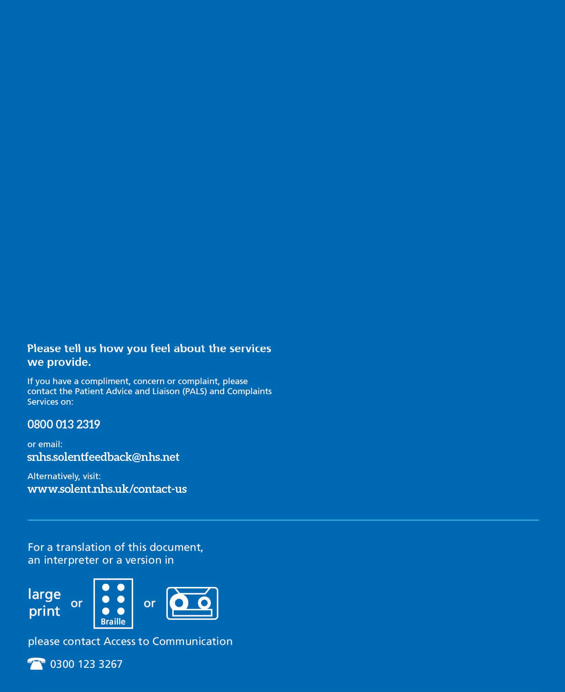

21

