

1

**Diversity, Inclusion and Belonging**

**Annual Report 2022**

**Author**

**Anna Rowen**

**Associate Director Diversity, Inclusion**

**and Belonging**

**August 2022**

Contents

Delivering Action to Improve Diversity & Inclusion and Belonging at Solent NHS 4

Introduction 4

People Strategy 4

Diversity, Inclusion and Belonging within our People Strategy 4

Diversity Inclusion and Belonging in Solent NHS 6

Delivering on Standards for Diversity & Inclusion 7

NHS Standards ‐ EDS3 Pilot Progress 7

NHSE Workforce Race Equality Standard (WRES) 8

Board Representation 8

Where we have seen improvement: 11

Where we need to improve 12

NHS Workforce Disability Equality Standard (WDES) 13

What we have seen improvement: 14

Where we need to Improve: 15

Gender Pay Gap 2022 16

Sexual Orientation Standard (SOM) 20

Analysing Diversity & Inclusion Workforce Data at Solent NHS Trust 21

Occupations by Ethnicity 21

Age of workforce 23

Sexual Orientation 24

Occupation by Gender 24

Disability 25

Religion 26

NHS Jobs – applications, shortlisted and appointed 27

Patient and Service User Data 28

Patients (Different Protected Characteristics) 28

Complaints April 2021‐ March 2022 29

Diversity & Inclusion Action Plan 2022- 2023 30

Significant projects to improve Diversity, Inclusion and Belonging in Solent. 31

The Big Conversation 31

Anti-discrimination and Hate Crime Reporting 32

Reciprocal Mentoring 33

Leadership Development for colleagues from ethnic minority 33

Diversity, Inclusion, and Belonging Roadshow 33

Turning the Tide 34

Equality Impact Assessment 34

Improving Education, Awareness and Allyship – An Organisational Development approach to improving inclusive culture 34

Inclusive Language Campaign and safe space sessions 36

Staff Networks 36

Responding to Covid ‐19 38

NHS Solent Roving Vaccination Service Supporting our Most Vulnerable Communities 38

Occupational Health 39

Building community confidence in the covid vaccine 41

Understanding the barriers faced by minoritised Communities from accessing Mental Health Services’. 41

Chaplaincy Service 42

Appendices 43

Diversity and Inclusion Action Plan 43

WRES and WDES data Table 43

Patient Information data tables 43

Hampshire County Council Equality and Diversity Profile 2011 Census 43

EDS Summary Report 43

# Delivering Action to Improve Diversity & Inclusion and Belonging at Solent NHS

# Introduction

This paper provides a Diversity & Inclusion update to the People Committee and Trust Board.

The Trust has a statutory obligation under the Equality Act 2010 to publish a range of monitoring information relating to patients and staff. This report is one of the ways in which the Trust fulfils its obligations.

This report provides the People Committee and the board with an update and progress report in relation to the EDS3 (Equality Delivery System3, NHSE workforce standards, Gender Pay Gap and contributes to meeting our PSED [Public Sector Equality Duties]).

By publishing our annual data on the Trusts main functions in relation to diversity and inclusion we are adhering to our Public Sector Equality Duties (PSED) obligations and our moral and social responsibility as a health care provider, employer and anchor organisation.

# People Strategy

The national NHS People Plan sets out an ambitious vision for the NHS, with more staff, working differently, in a compassionate and inclusive culture. It focuses on how we must all continue to look after each other and foster a culture of inclusion and belonging, as well as action to grow our workforce, train our people, and work together differently to deliver care.

Within Solent the Great Place to Work strategy, which is at the centre of our ‘3 greats’ Trust strategy, is based on the well-known evidence, that creating a highly motivated, engaged workforce has a positive impact on patient care and outcomes.

## Diversity, Inclusion and Belonging within our People Strategy

Our D&I strategy is embedded in and integral to Solents People Strategy.

Solents People Strategy has 4 themes:

1. **Looking after our People:**
   * Strategic Objective: We are committed to raising the health and wellbeing within the organisation – so that our people are supported to ‘Be here, Be Happy and Be Healthy
2. **Belonging in the NHS:**
   * Strategic Objective: We want to enable every person working in Solent NHS Trust to bring their authentic self to work each day, ensuring we all feel visible, and our identity and contribution is validated and valued.
3. **New Ways of working:**
   * Strategic Objective: We will work closely with our services to support programmes of improvement, change and innovation in the way we manage our workforce. We will embed strategic workforce planning in everything we do so we can harness the talents of our people through effective talent management conversations.
4. **Growing for the future:**
   * Strategic Objective: We are committed to developing a sustainable workforce and will attract, develop, reward and retain diverse talent who want to be part of a great place to work & thrive.

Whilst diversity, inclusion and belonging runs through all the strategic themes it is theme 2, Belonging in the NHS that is the primary strategic pillar that strategically drives our Diversity Inclusion and Belonging Action Plan.

The People Strategy will drive us forward in our commitment to an inclusive culture across the organisation to ensure that all members of our staff, patients, carers, volunteers, and visitors feel valued when they connect with our services.

* + - We want to make it easy for our diverse communities to access our services
    - We want to recruit and retain staff from diverse communities
    - We want all our staff and those who use our services to be valued and respected as individuals
    - We want to offer and provide learning and development opportunities to our diverse workforce

Our Board and senior leadership team support this agenda by:

* + - modelling the behaviors from our HEART values to promote a positive inclusive culture in the organisation
    - providing the resources required to deliver on Trust wide Diversity, Inclusion and Belonging programmes
    - working in collaboration with our systems partners and communities
    - having oversight to ensure that our PSED (Public Sector Equality Duties) are being effectively implemented
    - actively sponsoring our staff networks and empowering staff voice

The Associate Director of Diversity, Inclusion and Belonging has a key role in:

* + - helping to raise the profile of Diversity, Inclusion and Belonging internally and externally at Solent NHS Trust
    - providing expertise and senior leadership to the Trust Board and Executives and other senior managers across the Trust
    - supporting senior leaders to develop inclusive cultures within their service lines
    - providing robust and accountable leadership to ensure that successful outcomes are delivered in line with those laid out within the Diversity, Inclusion and Belonging Plan
    - ensuring robust performance, accountability and governance systems are in place
    - modelling active allyship and inclusive leadership

The Trust is committed to ensuring that the NHS England’s workforce equality standards (WRES and WDES) are embedded into its People Strategy and Diversity, Inclusion and Belonging Action Plan.

It has, and continues to engage with third sector organisations, regional & national networks, to learn and share best practice. This strategy runs parallel with the Alongside Communities Strategy and the deliverables of both plans dovetail to further strengthen the outcomes of each.

## Diversity Inclusion and Belonging in Solent NHS

The 2022/ 23 action plans aims to, ensure every person working in Solent NHS Trust is able bring their authentic self to work each day, ensuring we all feel visible, and our identity and contribution is validated and valued.

Solent NHS Trust has made advances on building an inclusive culture and this was evidenced in this year’s staff survey results where our engagement score rose by 2% and was our highest yet at 68%.

We scored amongst the best performing trusts of our type in 3 out of 9 themes, those being:

* We are compassionate and inclusive
* We each have a voice that counts
* Staff Engagement

Research shows that if we make improvements on race equality, we will make advances on all nine protected characteristics.

Therefore, we have used the Workforce Race Equality Standard (WRES) methodology at Solent with the aim of improving on the following as part of our commitment to the 10-year WRES plan:

* Increase our talent pool of BAME staff
* Ensure there is an equitable process for BAME staff in relation to Disciplinary and Grievance
* Improve our understanding on blind‐spots in the recruitment process

We have also worked to use the Workforce Disability Equality Standard (WDES) with the view to ensuring our commitment to improving diversity, inclusion and belonging.

We aim to ensure that our community partners reflect our diverse communities in areas we work in and have been involved in creating the Alongside Communities Strategy.

We intend to continue to improve our data collection by offering support through our learning and development team with self‐identification and refreshing data for our workforce and patients.

# Delivering on Standards for Diversity & Inclusion

## NHS Standards ‐ EDS3 Pilot Progress

Solent NHS Trust provides services across richly diverse communities, and this should influence how we provide our services as well as how we treat our staff, both current and future.

All NHS organisations are encouraged to use the EDS (Equality Delivery System). It sets out four goals around equality, diversity and human rights, and standards relating to those goals.

Solent NHS Trust working with their staff and the people who use our services assess their position against the standards and use that to help set improvement aims for the future

.

There are four goals:

* Better Health Outcomes for all aligned to Core20PLUS5
* Improved patient access and experience
* Empowered, engaged and well supported staff
* Inclusive leadership at all levels

Solent NHS Trust has signed up to the EDS 2022 test site which will focus on equality for patients, workforce health and wellbeing using data generated from sources such as WRES (Workforce Race Equality Standard) and WDES (Workforce Disability Equality Standard).

It will also focus on the accountability of leaders requiring evidence of how they personally commit and contribute to equality, diversity inclusion and health inequalities agendas.

# NHSE Workforce Race Equality Standard (WRES)

Evidence shows that a motivated and inclusive workforce results in better patient care and increased patient satisfaction and safety. The Workforce Race Equality Standard (WRES) is a set of 9 indicators that are used to measure workforce race equality and has been mandated through the NHS standard contract since 2015‐16. The metrics for indicators 1 – 4 are taken from ESR data, 5 – 8 from the NHS staff survey results and metric 9 from Trust Board.

All workforce data has been taken from the ESR records dated 1st April 2021 to 31st March 2022. This data is then fed into the WRES report for 2020. The data covers staff categorised under the Agenda for Change. Please note that the WRES team only ask for data on substantive staff.

In 2022 there were 4,207 members of substantive staff, of which 10.7 % (9.6% on 31/2/21) were from a BAME background. The BAME population of Hampshire is 8.2% (Hampshire County Council) illustrating that our staff are representative of the populations that we serve. *Source* [*Hampshire County Council Area v1.xls (hants.gov.uk)*](https://documents.hants.gov.uk/EqualityandDiversityFactsheet-HampshireCountyCouncilArea.pdf) *– N.B this is the most up to date data – the results for census 2021 will be publish with all other main Census 2021 data within two years of the census. Ethnic group statistics will first be available as a topic summary between autumn to winter 2022.but at the time of writing this report this data is mot available.*

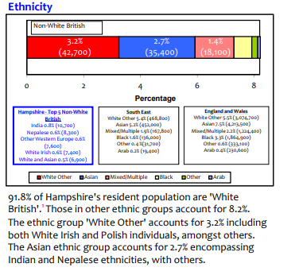

## Board Representation

As of reporting of 31st March 2021 and today 24.08.22 - 17% of the board are from BAME backgrounds

|  |  |  |  |  |
| --- | --- | --- | --- | --- |
| **WRES Category** | **Headcount** | **Headcount %** | **Board Headcount** | **Board Headcount %** |
| BME | 452 | 10.74 | 2 | 16.67 |
| White | 3,711 | 88.21 | 10 | 83.33 |
| Z Not Stated/Not Given | 44 | 1.05 | 0 | 0.00 |

Across our total workforce we are representative of the population we serve, with 10.7% of colleagues from Black Asian minority ethnic backgrounds versus 8.2% of the Hampshire population.

And whilst colleagues from Black Asian minority background are also strongly represented in very senior management positions (VSM), the table on the left highlights those areas where there is some underrepresentation when you drill down to band. Our Diversity inclusion plan aims to address this in equality and under representation throughout all bandings.

Within clinical staff, whilst Black Asian minority colleagues are well represented in very senior management, medical and dental bands, they are clearly under-represented in bands 7, 8a and (in particular) band 9 compared to colleagues from a white background.

There is also an under-representation of colleagues in band 3 with only 5.3% of colleagues in this band of Black Asian minority background.

The wider issue appears to be in non-clinical staff, where colleagues from a Black Asian minority background are generally under-represented, accounting for only 8.1% of the workforce.

It is only the two ends of the grades at band 2 and 9 where they are over-represented.

|  |  |  |  |  |
| --- | --- | --- | --- | --- |
|  |  | **Headcount (%)** | | |
| **Clinical / Non-Clinical** | **WRES Banding** | BME | White | Z Not Stated/Not Given |
| Clinical | Band 2 | 21.7% | 77.7% | 0.6% |
| Band 3 | 5.3% | 94.4% | 0.3% |
| Band 4 | 10.2% | 86.7% | 3.0% |
| Band 5 | 19.6% | 79.3% | 1.1% |
| Band 6 | 8.4% | 90.8% | 0.8% |
| Band 7 | 6.7% | 92.9% | 0.4% |
| Band 8a | 7.8% | 90.9% | 1.3% |
| Band 8b | 8.9% | 91.1% | 0.0% |
| Band 8c | 9.5% | 90.5% | 0.0% |
| Band 8d | 9.1% | 90.9% | 0.0% |
| Band 9 | 0.0% | 100.0% | 0.0% |
| VSM | 15.8% | 84.2% | 0.0% |
| Medical & Dental Consultant | 41.7% | 58.3% | 0.0% |
| Medical & Dental Non-Consultant Career Grade | 31.6% | 63.3% | 5.1% |
| Medical & Dental Trainee Grades | 24.1% | 72.4% | 3.4% |
| Non Clinical | Band 2 | 15.3% | 83.8% | 0.9% |
| Band 3 | 4.8% | 94.4% | 0.8% |
| Band 4 | 4.2% | 94.4% | 1.4% |
| Band 5 | 6.3% | 91.3% | 2.4% |
| Band 6 | 4.0% | 93.3% | 2.7% |
| Band 7 | 9.8% | 90.2% | 0.0% |
| Band 8a | 5.0% | 92.5% | 2.5% |
| Band 8b | 4.3% | 95.7% | 0.0% |
| Band 8c | 5.3% | 94.7% | 0.0% |
| Band 8d | 0.0% | 100.0% | 0.0% |
| Band 9 | 20.0% | 80.0% | 0.0% |
| VSM | 50.0% | 50.0% | 0.0% |

**Table - Breakdown of staff banding and ethnicity**

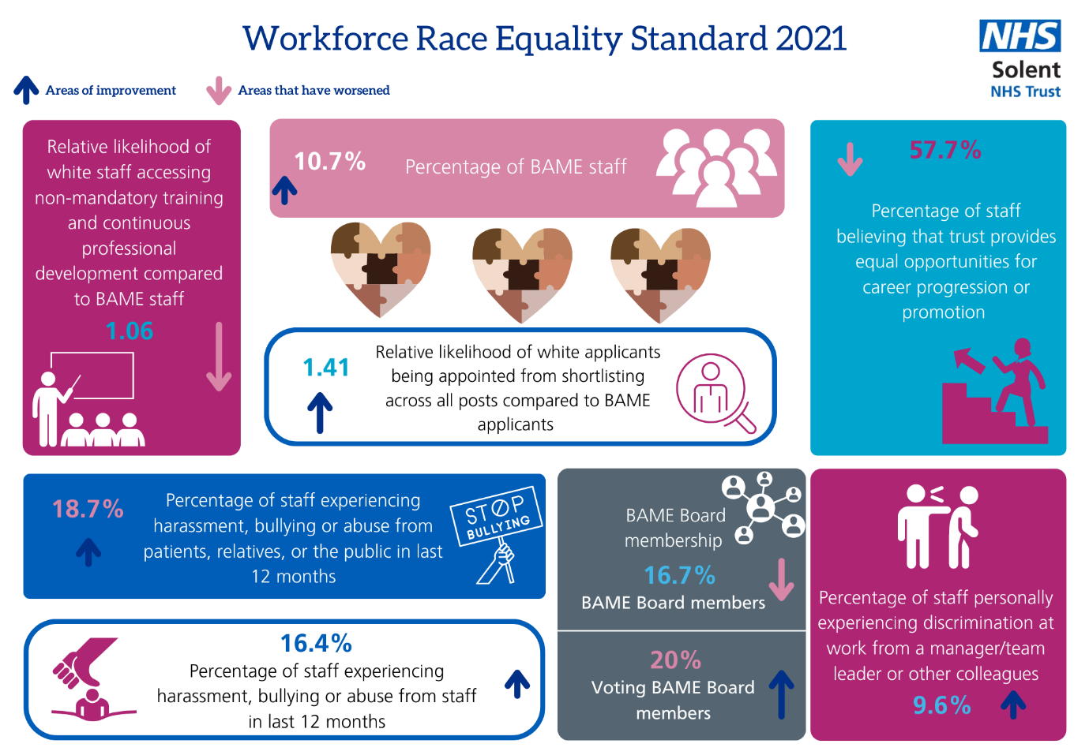

Work themes in place to address these issues include (please see full action plan for further detail):

* Pilot Leadership development and coaching Programme for colleagues from ethic minority background
* Planned Reciprocal/ Reverse Mentorship for Inclusion Programme
* Sharing job opportunities with Community Partners
* Deep Dive and overhaul of practice into our attraction and recruitment practices
* The Big Conversation
* Working with specific workstreams across HIOW ICS (Hampshire Isle of Wight Integrated Care System) focusing on recruitment, retention, and talent management
* Anti‐Discrimination Taskforce and introduction of a 2steps hate crime reporting system
* Education, awareness and allyship programs
* As well as the insights from the big conversation the networks have continued to provide a safe space for colleagues to discuss what is important to them. Since the start of 2022 we have changed the way in which the networks voice cascades up, down, and out of the networks. We have delayered the levels of assurance and accountability and provided admin resource. This is in response to feedback that actions from the network groups took too long to realise. Networks now feedback into People Forum and other relevant agendas so to ensure momentum and action is efficient.

## Where we have seen improvement:

* The BAME network is a safe space for people to share their experiences and learn from others. Ongoing promotion of Freedom to Speak Up for BAME staff continues, which enable staff the opportunity to raise concerns in a confidential and safe environment.
* Within the National WRES 2022 report, Solent was mentioned as 1 of the top 10 performing trusts for indicator 6: Percentage of BME staff experiencing harassment, bullying or abuse from staff in the last 12 months. This is testament to the work that took place last year after last year’s results. We have improved significantly on this indicator and gone from 18.1% to 16.4%.
* The 2020 staff survey showed an increase of 4.3% of staff who had experienced discrimination at work from a manager/team leader or other colleague. However, this year (2021) significant improvement has been seen and exceeded our 10% target - a reduction of 4.2% bringing the percentage down to 9.6 % of staff who have experienced discrimination from a manager, team leader or colleague. When looking at this improvement it also is better than the benchmark trend.

|  |  |  |
| --- | --- | --- |
| * BAME board membership - Percentage difference between the Board’s voting membership and its overall workforce * **Target: Increase diversity of board membership when vacancies arise.** | | |
| * 2019 * 15.4% BAME Board members * 18.2% Voting BAME Board members | * 2020 * 21.4% BAME Board members * 18.2% Voting BAME Board members | * 2021 * **16.7%** BAME Board members * **20.0%** Voting BAME Board members |

* Improvement has also been seen in WRES indicator 5: Percentage of staff experiencing harassment, bullying or abuse from patients, relatives, or the public in last 12 months where we have exceeded the target of 20% and reduced from 2

Board diversity is important to avoid group think, and it allows more nuanced discussions that will reflect the colleagues that work for Solent and the communities we serve.

Solent is proud to have its Chief People Officer as its Board level BAME Sponsor as recommended in the 5 ambitions of BAME Networks by NHS England (*BAME staff networks in NHS Organisations, 2020*).

*NB: To graphical representation of this see appendix of WRES and WDES Graphical Benchmark Data*

## Where we need to improve

* The latest WRES data, submitted in August 2022 shows that whilst we have made progress with regards to ensuring we have greater representation of Colleagues from BAME backgrounds, we still have some work to do in this area. We will also be reviewing the target over the next year to ensure that it is representative of the latest community and census data.
* Indicator 2 of the WRES: Relative likelihood to white staff being appointed from shortlisting has not shown any improvement. Whilst the proportion of BAME staff being shortlisted in encouraging at 19%, this is not following through to appointments with only 16% of appointments from BAME backgrounds. However, it is encouraging that both of these are above the current proportion of BAME staff in the trust (10.7%)
* Indicator 4 of the WRES: Relative likelihood of white staff accessing non-mandatory training and continuous professional development (CPD) compared to BAME staff, has this year increased from a 1.02 to 1.06 relative likelihood. This is perhaps not surprising as the impact of covid has meant that all colleagues have been less likely to complete non statutory training. It is also worth noting that the reliability and quality of this metric is questionable as it relies on colleagues self-reporting and logging all CPD on ESR.
* However, given that indicator 7: Percentage of staff believing that trust provides equal opportunities for career progression or promotion is also telling us that whilst there is a small increase of staff from 56.1% last year (and from 47.9% the previous year) to 57.7% this year, positive action is required to ensure there is greater equity of access of CPD for colleagues from a BAME background. As such this will be a focus and key deliverable within this year’s plan. This will include the roll out of another leadership development and coaching program for BAME colleagues and the introduction of a reciprocal/ reverse mentoring program**.**

# NHS Workforce Disability Equality Standard (WDES)

The WDES are a set of ten specific metrics that compare the workplace experience of staff with a disability and non‐disabled staff. It allows the Trust to understand the experiences of their staff with a disability and plan to create a more inclusive work environment. As with the WRES the metrics are taken from both ESR and staff survey results.

All workforce data has been taken from the ESR records dated 1st April 2021 to 31st March 2022. This data is then fed into the WDES report for 2020. Please note that the WDES team only ask for data on substantive staff.

In 2022 there were 4,207 members of substantive staff, of which 3.9% had a known disability.

This data is being collected as part of the 2022 data collection for the Workforce Disability Equality Standard (WDES). The aim of WDES is to improve the working and career experiences of Disabled staff in the NHS. The WDES is mandated through the NHS Standard Contract and has been approved as a data collection by the NHSX Data Alliance Partnership. It has also been subject to a data protection impact assessment.

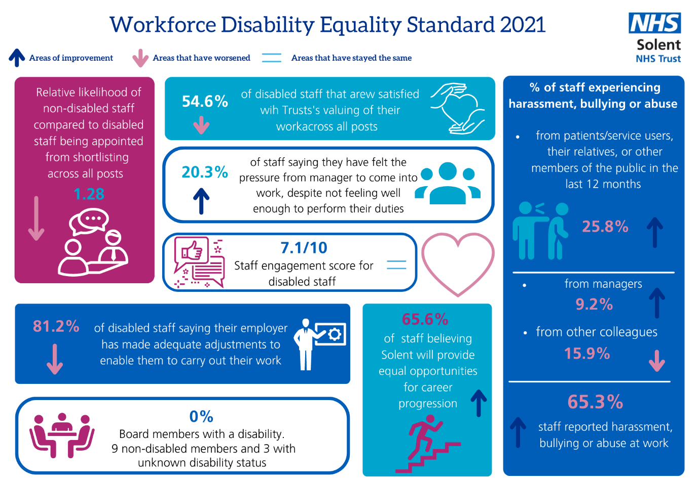

Solent NHS Trust’s workforce is made up of 3.9% of staff with a known disability, although a further 18.7% have not declared their status.

There is clearly a need to encourage more people declaring their disability status, particularly amongst the medical and dental community where there are potentially process issues to investigate in collecting this information.

On both the clinical and non-clinical sides our workforce is under-represented in the upper bands of 8c and above, something that is certainly worth exploring in our diversity and inclusion plan.

|  |  |  |  |  |
| --- | --- | --- | --- | --- |
|  |  | **Headcount (%)** | | |
| **Clinical / Non-Clinical** | **WRES Banding** | Disability | No Disability | Unknown |
| Clinical | Band 2 | 1.8% | 77.7% | 20.5% |
| Band 3 | 3.6% | 83.2% | 13.2% |
| Band 4 | 4.5% | 79.9% | 15.5% |
| Band 5 | 6.3% | 83.2% | 10.5% |
| Band 6 | 4.9% | 79.3% | 15.8% |
| Band 7 | 3.9% | 77.8% | 18.3% |
| Band 8a | 3.2% | 71.4% | 25.3% |
| Band 8b | 2.2% | 75.6% | 22.2% |
| Band 8c | 4.8% | 57.1% | 38.1% |
| Band 8d | 9.1% | 90.9% | 0.0% |
| Band 9 | 0.0% | 100.0% | 0.0% |
| VSM | 0.0% | 63.2% | 36.8% |
| Medical & Dental Consultant | 3.3% | 40.0% | 56.7% |
| Medical & Dental Non-Consultant Career Grade | 2.5% | 70.9% | 26.6% |
| Medical & Dental Trainee Grades | 0.0% | 10.3% | 89.7% |
| Non Clinical | Band 2 | 2.3% | 76.0% | 21.7% |
| Band 3 | 2.9% | 79.1% | 18.0% |
| Band 4 | 2.8% | 74.5% | 22.7% |
| Band 5 | 7.4% | 68.0% | 24.6% |
| Band 6 | 2.9% | 74.3% | 22.9% |
| Band 7 | 3.7% | 78.0% | 18.3% |
| Band 8a | 5.0% | 77.5% | 17.5% |
| Band 8b | 4.5% | 63.6% | 31.8% |
| Band 8c | 0.0% | 94.7% | 5.3% |
| Band 8d | 0.0% | 78.6% | 21.4% |
| Band 9 | 0.0% | 100.0% | 0.0% |
| VSM | 0.0% | 76.9% | 23.1% |

**Table - Breakdown of staff banding and disability**

## What we have seen improvement:

* Improvements have also been seen in indicator 4 of the WDES, Percentage of staff experiencing harassment, bullying or abuse from patients/service users, their relatives, or other members of the public in the last 12 months – with a reduction from 27.7% last year and 29.1% the year before to 25.8% this year. This has bucked the trend as the benchmark data has increased slightly. Overall, there has been improvement in this however we continue to focus on raising awareness and understanding to ensure that we see a positive progression in the % of staff experiencing harassment, bullying or abuse from other colleagues in the last 12 months.
* Indicator 4b has seen in increase in the % of colleagues taking action to report. This has gone from 58% last year to 65.3% this year. This correlates with the freedom to speak up index and is indicative of the work that has taken place to create a psychological safe space for colleagues to raise concerns. This is a notable increase and also goes against the benchmark trend which is stable. Specific work has taken place to improve a culture of speaking up as this was highlighted as an area in the well led review that took place towards the end of 2021 that needed further work.
* The other indicator that has seen significant improvement is indicator 6: Percentage of staff saying that they have felt pressure from their manager to come to work, despite not feeling well enough to perform their duties. This has reduced to 20.3% from 25.9% last year and 27.8% the year before. We have taken proactive action to support managers to have health and wellbeing conversations with colleagues as part of appraisals and 121s, this increase indicates a positive influence on this indicator. There has been significant investment and promotion of the Health and Wellbeing Being Plan to support colleagues in staying healthy and well at work.

## Where we need to Improve:

* We have seen a decline in metric 2 of the WDES with the relative likelihood to disabled staff being appointed from shortlisting back to the level it was at 2 years ago, with non-disabled staff now 28% more likely to be appointed. Work stream one of the Diversity and inclusion plan aims to ensure the recruitment process is more inclusive and free of bias. The creation of the new Disability and advisory service that was an idea generated form the Disability Network in Solent is underway and will remain an area of improvement for this year.
* The latest WDES indicators show that we still have work to do with regards to indicator 7: Percentage of staff saying that they are satisfied with the extent to which their organisation values their work. This has remained relatively static, last year at 54.3% to this year 54.6% saying they feel valued. As such further focused work will take place this year to ensure that we can meet our target of 60%. This is detailed in the Diversity and Inclusion Plan.
* Indicator 8: Percentage of disabled staff saying that their employer has made adequate adjustment(s) to enable them to carry out their work, shows a decrease from 86.4% to 81.2% - this will remain a priority for this year. We are working with our colleagues in the ICS to implement a neuro divergent and disability service and we will be looking to review the way access to work funds are managed as well as co creating and implementing an accessible arrangements policies and standard operating procedure. Staff voice from the DisAbility network further corroborates this metric.

*NB: To graphical representation of this see appendix of* *WRES and WDES Graphical Benchmark Data*

Actions that have been taken to improve the work experience of staff with a disability include:

* Reciprocal / Reverse Mentorship for Inclusion Programme being developed
* Deep Dive and overhaul into our attraction and recruitment practices
* The Big Conversation
* Anti‐discrimination Taskforce and the implementation of a 2-step hate crime reporting system
* Solents Disabilities Awareness Day Conference and managers training
* Refreshed Terms of reference and Executive sponsorship
* Delayered accountability and assurance framework that supports actions and outcomes and empowers staff voice
* Winter survey that will inform specific action planning to improve inclusion for colleagues with a disability or long-term illness
* Planned and well-advertised events

# Gender Pay Gap 2022

Under the equality act 2010, regulations 2017, every employer who has 250 or more employees is required to publish their gender pay gap for workers in post as of the 31st of March each year, which has to be published by the 30th of March the following year.

**Snapshot date 31 March 2022**

Based on average rates of pay, the gender pay gap for Solent NHS Trust on 31 March 2022 is 11.83% in favour of male employees; (an improvement from 2021 at 12.87%), the median pay gap is 0.55% (a decrease from 2021, 2.37%).

The gap for average bonus payments is 5.1% in favour of male employees (an increase on 2021, -2.8%), the median gap for bonus payments is 0% (the same as reported in 2021).

During years 2020/21 and 2021/22, to recognise the additional pressure of responding to Covid-19, Clinical Excellence Awards (CEA) were made to all eligible consultants (usually consultants are required to apply for awards), the awards were of equal value and were paid in full regardless of contracted hours worked.

This change had an extremely positive effect upon our gender bonus pay gap. Had the CEA’s not been applied as described above the gap for average bonus payments would be 45.84% which is in line with pre-COVID reporting. The Trust may find that next year the bonus gap reverts to a similar level to that of pre-COVID, as the application of CEA is being reviewed and is likely to return to a similar criterion for application pre-COVID.

Males account for 13% of the Trust overall workforce this has slightly decreased from 2021, where it was reported 14% of the workforce was male. This slight increase of females entering the Trust may explain some of the changes in the overall results. It should also be noted that whilst the overall gender pay gap may have only slightly reduced because of the change in Chief Executive. The previous Chief Executive left the organisation in February 2022 and therefore would not have been captured in this date and their departure would have impacted the over figures.

**Ordinary Pay**

The hourly rate is calculated for each employee based on “ordinary pay” which includes basic pay after any salary sacrifice deduction for childcare vouchers or nursery fees direct has been deducted, recruitment and retention payments, enhancements, on-call payments, additional hours/sessions, pay protection payments, additional responsibility payments, essential user for travel allowances.

**Bonus Payments**

As an NHS organisation, the only pay elements that fall under the bonus pay criteria are clinical excellence awards which are paid to eligible Medical and Dental consultants.

With regard to Bonus payments, many of the male staff receiving Clinical Excellence Awards have historical awards delivered as part of their ordinary pay. Our male staff predominantly work full time, thereby receiving a full award. Many of our Female consultant staff work part time and the award has historically been prorated to reflect this.

**Comparators**

When comparing our gender pay gap with local NHS provider trusts within HIOW Integrated Care System, Solent continues to reflect the lowest Gender Pay Gap (Average range of comparators reporting for year 2019/2020 is 19.2%- 24.3%, Median range 4.9% – 10.1%). Solent generally falls within the mid-range when comparing gender bonus gaps with the same comparator group.

**Part-time employees**

It has been observed in prior reporting periods that part time staff can be disproportionately affected, specifically when considering payments which are pro-rated and/or ad-hoc. Where the majority of our staff are paid within the agenda for change framework and as a result roles are subject to job evaluation, the risk of any individual being paid disproportionately for work of equal value is low.

**Summary information**

An illustration of Solent NHS Trusts gender pay journey can be found over page:



Ongoing actions include:

* We will continue to work with existing female staff to understand opportunities and potential barriers to development and promotion and de bias or recruitment and development processes.
* Continuing focus on the intention to use positive action for Clinical Excellence Awards including promotion of applications from female consultants. Legacy clinical excellence awards are reviewed after 5 years.
* During years 2020/21 and 2021/22, CEA awards are being made to all eligible consultants, the awards are of equal value and are paid in full regardless of contracted hours worked. Our local Doctors and Dentists Negotiating Committee (DDNC) are empowered to make local decisions in relation to aspects of the allocation of Clinical Excellence Awards.
* Continue to focus on improving the attractiveness of roles which are historically female dominated to potential male candidates. This will be delivered through work stream one of the D&I plan for 22/23 – Overhaul of attraction and recruitment to ensure more inclusive practice. The number of male employees rose from 397.17fte in 2018/19 to 453.50fte in 2020/21.
* Continue to promote salary sacrifice schemes (childcare vouchers) to male colleagues (alongside other inclusion initiatives such as shared parental leave).

*We did not see any change in the number of males claiming salary sacrifice for childcare between 31 March 2019 and 2021.*

# Sexual Orientation Standard (SOM)

The SOM provides a consistent mechanism for reporting the sexual orientation of services users aged 16 and over.

However, it is not mandatory to collect this information at present. Nevertheless, Solent are keen to collect this data as it will allow us to better identify health risks and will help support targeted, preventative, and early intervention work to address the health inequalities for our LGB (Lesbian, Gay and Bisexual) service users.

Research shows that LGB people are more likely to miss out on routine health screening and are at increased risk of poor mental health. As a community and mental health Trust this is hugely important.

Work started on the SOM implementation last year with a task and finish group established.

Early engagement work with staff commenced, but further work had to be put on hold due to Covid‐19. It is intended that this will recommence at the start of 2023.

# Analysing Diversity & Inclusion Workforce Data at Solent NHS Trust

The following staff data is as of 31 March 2022 where the total number of substantive staff was 4,207 and provides a snapshot of our staff. Data below is for substantive staff only.

## Occupations by Ethnicity

|  |  |
| --- | --- |
| **Ethnicity** | **% Workforce** |
| BAME | 10.7% |
| White | 88.2% |
| Not Stated | 1.1% |

**Table Ethnicity of staff**

*For more detailed analysis of Solent’s NHS Trust’s workforce ethnicity profile see the Appendix ‘Solent NHS Trust Ethnicity Detailed Breakdown 2122’.*

A deep dive into recruitment has been carried out to ensure that Solent is truly inclusive in its recruitment, and subsequent action plan developed.

Solent are also working with colleagues across the ICS to address recruitment and retention of BAME staff, as well as focusing on a service line level.

Workstream 1 of the diversity and inclusion plan aims to:

Re – design the attraction, recruitment and onboarding process to increase diversity and improve inclusion

Key Success indicators outputs and outcomes will be:

* Working with community partners to access underrepresented communities
* Working with Networks for co-production
* Redesigning Job adverts and JDs
* Implementing Oleeo system
* Redesign of assessment process
* Development and implementation of a diverse Bank of Inclusion Ambassadors *(LH)
* Implementation of comply and explain
* Increase of shortlisted and successful applicants from diverse back grounds
* Train the trainer scalable inclusive recruitment workshop to embedded new ways of working / recruitment
* Improved more accessible volunteering pathways to recruitment (Community Engagement)
* Positive impact on WRES, WDES, MWRES indictors

## Age of workforce

|  |  |
| --- | --- |
| **Age** | **% Workforce** |
| <=20 Years | 1.6% |
| >=71 Years | 0.8% |
| 21-25 | 6.2% |
| 26-30 | 9.5% |
| 31-35 | 12.9% |
| 36-40 | 11.7% |
| 41-45 | 11.8% |
| 46-50 | 12.0% |
| 51-55 | 12.6% |
| 56-60 | 11.8% |
| 61-65 | 7.7% |
| 66-70 | 1.5% |

**Table Age of workforce**

A large proportion of our staff working for the Trust are aged between 46‐55. This suggests that the Trust needs to have plans in place to support an ageing workforce.

This year a new staff network has been established with an executive sponsor.

The 50+ Staff Network is a proactive space for connection, support, advocacy, action and education for staff aged 50+. They meet regularly throughout the year and collaborate to explore issues that have been raised and that are important to our colleagues. They are about inspiring change and making sure our Trust is age inclusive, with a focus on health and wellbeing, addressing inequalities and challenging stigma.

This network has newly formed and has started to make enquiries around how best to support people nearing retirement to work out the financial impact of stepping down.

The lowest age group that is represented is those who are aged 71 or over and for those aged 20 or younger.

## Sexual Orientation

|  |  |
| --- | --- |
| **Sexual Orientation** | **% Workforce** |
| Heterosexual or Straight | 79.3% |
| Bisexual | 1.3% |
| Gay or Lesbian | 1.6% |
| Other/Not stated (person asked but declined to provide a response) | 17.7% |

**Table Sexuality of workforce**

* Solent has a thriving LGBT+ Allies Resource Group, and further details of their activity are listed later in the report.
* The LGBTQ+ Staff Network provides a space for LGBT+ staff and allies to come together and talk, share and connect with each other in a safe and positive environment. The network promotes a working environment where all LGBTQ+ staff feel supported, valued and able to be themselves without fear of prejudice. They also enable staff to achieve their potential, challenge discrimination and positively promote equality and acceptance.
* They are working with our colleagues in Estates to create gender neutral facilities across the Trust footprint.
* Over the past year a Stonewall audit was commissioned and the outcome of this audit has resulted in a detailed action plan being co designed with the network to ensure better inclusion for LGBT+ colleagues. This is in co creation phase at the moment and will be implemented and action over the next year – a full update on progress will be included in next years annual report and regular updates on progress will be made to People Forum and Committee throughout the year.
* The data indicates that a significant proportion of the workforce have not provided an answer to this question. The reasons for this are, of course, multifaceted, but we need to ensure that our staff are not leaving this question unanswered because they fear discrimination.

## Occupation by Gender

|  |  |
| --- | --- |
| **Gender** | **% Workforce** |
| Female | 85.8% |
| Male | 14.2% |

**Table Gender of workforce**

Solent has a predominantly female workforce, and this has also been highlighted in the Gender Pay Gap report. However, currently the national ESR (Electronic System Recording) system only allows individuals to categorise themselves as male or female and there is no option for non‐binary staff. This is something that needs to be addressed at a wider level and raised through the HIOW.

## Disability

|  |  |
| --- | --- |
| **Disability** | **% Workforce** |
| Yes | 3.9% |
| No | 77.3% |
| Not stated | 18.7% |

**Table Disabled and non‐disabled staff**

|  |  |
| --- | --- |
| **Type of Disability** | **% Disabled Workforce** |
| Unspecified | 40.3% |
| Learning disability/difficulty | 22.8% |
| Long standing illness | 15.7% |
| Physical impairment | 9.9% |
| Sensory impairment | 5.3% |
| Mental health condition | 4.3% |
| Other | 1.8% |

**Table Type of Disability disclosed**

A large proportion of staff have not answered this question. Solent are committed to ensuring that staff with a disability are supported and that staff feel able to declare their disability without fear of judgement or discrimination.

With regards to improvements on our WDES indictors we have seen improvement in the % of colleagues who disclose their disability – seen an improvement that exceed our target from 20.6% of disability status not know to a reduction of 18.7%.

A disability awareness conference and Manager training is being arranged for the end of 2022 - more information about this is included in the WDES section of this report.

Solent’s People Strategy has 4 key themes – one of which is

‘Belonging within the NHS’.

The key focused priority for this theme is to:

*“Enable access and inclusion for all with an initial focus on disability and long-term conditions with aim of widening to other groups as we make progress.”*

## Religion

|  |  |
| --- | --- |
| **Religious Belief** | **% Workforce** |
| Christianity | 45.7% |
| Atheism | 18.0% |
| Islam | 1.8% |
| Hinduism | 1.0% |
| Sikhism | 0.6% |
| Buddhism | 0.5% |
| Judaism | 0.1% |
| Other | 9.4% |
| Unspecified | 0.6% |
| I do not wish to disclose my religion/belief | 22.3% |

**Table Religion of workforce**

* Our Multifaith Staff Network supports human flourishing in our workplaces. Bringing staff together to celebrate all our diversity of faiths or none, beliefs and cultures in our Trust.
* This network shares knowledge and encourages staff to feel safe to express their faith in the workplace. They offer a safe space for everyone to have a time for reflection and stillness, paying attention to our spirituality is a key element of on-going mental wellbeing.
* The multifaith resource group has been particularly active and supportive to staff throughout the pandemic. Solent’s Chaplain has provided a lot of support of staff of all faiths and none.

# NHS Jobs – applications, shortlisted and appointed

Solent’s recruitment data and WRES shows the relative likelihood of white applicants being appointed from shortlisting across all posts compared to BAME applicants as follows:

|  |  |  |
| --- | --- | --- |
| Relative likelihood of white applicants being appointed from shortlisting across all posts compared to BAME applicants  **Target: decreased to 1.2 by July 2022** | | |
| 2019  1.40 | 2020  1.36 | 2021  **0.94** |
| This is a significant improvement and is a result of the proactive work that has taken place to debias the recruitment process. | | |

Solent’s recruitment data and WDES shows the relative likelihood of non-disabled applicants being appointed from shortlisting across all posts compared to applicants with a disability as follows:

|  |  |  |
| --- | --- | --- |
| Relative likelihood of non-disabled staff compared to Disabled staff being appointed from shortlisting across all posts  **Target: Equal likelihood of non-disabled staff being appointed from shortlisting across all posts by July 2022** | | |
| 2019  1.20 | 2020  1.06 | 2021  **1.22** |
| It is possible the 2020 the anomaly. Work stream one of the Diversity and inclusion plan aims to ensure the recruitment process is more inclusive is and free of bias. The creation of the new Disability and advisory service that was an idea generated form the Disability Network ins Solent is underway. This will remain an area of improvement for this year. | | |

Workstream one of the action plan relates to overhauling attraction and recruitment and implementing an inclusive recruitment toolkit for recruiting managers.

# Patient and Service User Data

## Patients (Different Protected Characteristics)

The data in the Appendix was extracted from the Power BI reports on 23/08/221.

It presents a snapshot of currently open referrals and those closed within the last 3 months.

There is variable recording on all protected characteristics.

* 100% of patients
* 13.34% disability status
* 20.38% Ethnicity/Race
* 96.38% Gender
* No information for gender reassignment
* 9.32% Marriage and Civil Partnership status
* 10% Religious beliefs

There is currently ongoing work in service lines, specifically in Child and Family and in Mental health to improve data collection. It is recognised it has never been more important and necessary as healthcare providers to ensure that the services being delivered not only meet the healthcare needs that are presenting, but also are structured and delivered in an inclusive way.

There continues to be 4 main aims the child and family Inclusion group is working on:

1. To gain greater clarity regarding the demographic and ethnographic backgrounds for children and families who receive care from Solent NHS Trusts children’s services as well as the broader public population in our delivery areas
2. To improve the capture and retrieval of the above information from SystmOne as the Trusts patient record system. A standardised template has been trailed in CAMHS for some time now and this needs to be broadened further across the whole service line
3. To engage with children and families who use healthcare services to ascertain guidance and direction from them about how we capture and then use their demographic and ethnographic information in the provision of our services. To capture lived experience of both C&F and staff where the approach taken has made a difference in terms of how healthcare is either received or delivered
4. To engage with staff teams to promote and communicate the importance of both working within and delivering an inclusive culture. Whereby staff are aware of demographic difference, positively reinforce it into the team culture and have sound knowledge and awareness of how this can drive service development

## Complaints April 2021‐ March 2022

There were 148 formal complaints from enquirers for the period April 2021‐March 2022.

Figures were up from the previous year due to the complaints process being closed during the first lockdown in April 2020 (only urgent complaints were responded to).

Historically, ethnicity and age groups of patients have been sought in our complaints feedback questionnaire, this form is sent to enquirers along with the formal response to their complaint.  (The data received from the questionnaires is held in a secure excel datasheet in the PALS and Complaints Service folder on the r:drive).

We have the function to request more information using our Ulysses Software, however, when an enquirer is making a complaint, it can be challenging to request the information at the first point of contact.  Our colleagues in the Quality Information and Systems Team are looking at ways to pull the data from our Patient systems into Ulysses.

In the near future we are going to offer enquirers an electronic version of our complaints feedback questionnaire this can be emailed out to enquirers, to ensure it is more accessible.

# Diversity & Inclusion Action Plan 2022- 2023

In December 2021 a strategic review was undertaken with regards to the diversity, inclusion and belonging function and purpose. This along with the recommendations of the well led review, the findings of the big conversation and analysis of the WRES, WDES and staff survey outcomes have determined the key areas of focus for following the year, March 2022 to March 2023.

Network chairs and members were both instrumental in the design and agreement of the plan and were engaged in the co creation of the plan. Colleagues from the community engagement team and representation from both clinical and corporate service lines were also involved from point of concept through to point of delivery. A collaborative approach to embedding diversity inclusion and belonging is what sits at the heart of the plan.

This plan is positioned in the context of supporting the Delivery of the NHS People and Operational Plan, The People Promise and Solent’s People Strategy, as well as aligned to ensure the delivery of positive improvement of the WRES and WDES indicators and ensure that we fulfil our requirements under the Public Sector Duty Equality Act.

The well led review that took place at the end of 2021 outlined the following with regards to improvements required pertaining to diversity, inclusion and belonging in Solent NHS Trust:

* *“Whilst experienced and observed positive culture, this was not uniform, and feedback suggested that there are pockets where the Trust can do more.”*
* *“The Trust recognised the need to put greater focus around the Equality, Diversity and Inclusion (EDI) agenda and the work around this is evident.”*
* *“Ensure that the EDI workstream secures parity of profile to other successful campaigns such as FTSU and staff wellbeing.”*
* *“The Trust is behind the EDI curve and requires commitment to improve awareness and understanding in this area.”*
* *“Potential concern whether, because staff are so genuinely happy to work at the Trust and believe in its culture and ethos, whether they feel hesitant in surfacing concerns.”*

The Plan aims to ensure that in Solent we ‘enable every person working in Solent NHS Trust to bring their authentic self to work each day, ensuring we all feel visible, and our identity and contribution is validated and valued’.

The Action Plan has 3 workstreams – all with specific deliverables which are aligned to ensuring delivery of positive progress against the WRES and WDES indicators as well as addressing and taking action considering the well led recommendations as outlined above.

The full plan can be found in the appendices.

A summary of the workstreams are detailed below:

# Significant projects to improve Diversity, Inclusion and Belonging in Solent.

## The Big Conversation

During 2021, Solent NHS Trust launched a suite of listening sessions, known as ‘The Big Conversation’, to better understand the experiences of staff across the Trust, with a particular remit to explore and hear about experiences of workplace discrimination and harassment.

The overall aim of this was to support the identification of issues related to anti‐discrimination including racism both direct and systemic, and co‐ design interventions to tackle these issues. This work was shaped by colleagues from our Staff networks.

The Big Conversation took an expansive approach beyond race and ethnicity also focusing on the following key staff network group areas/themes: BAME; LGBT+; Disability and Multi‐faith. It aimed to foster a leadership culture for all, framed around discrimination e.g., our behaviors set the standards of expectation we aspire to in our daily work.

Our Big Conversation helped us to hear the voices of under-represented groups.

We know that listening to the voices of people from underrepresented groups and acting on their feedback can lift the culture of the whole organisation.

The Big Conversation report reminds us not to be complacent around our inclusion agenda. Staff shared experiences of discrimination from patients who refused to be treated by them because of their ethnic origin, a female colleagues described how her concerns about travelling home late at night were ignored and she was told to ‘get a grip’. Another person described how our structures and processes disproportionately harm those with disabilities or long-term health conditions.

When analysing what staff felt contributed to discrimination in the workplace, the top three factors were cited as:

* Bias (personal and professional bias in decision making and actions)
* Education (that which is part of formative years, formal education and informal learning experiences in and outside of the workplace)
* Career opportunities (including but not limited to opportunities presented by Solent or the NHS more broadly

The recommendations of the report from the Big Conversation have informed and shaped the deliverables set out within the Diversity, Inclusion and Belonging plan.

## Anti-discrimination and Hate Crime Reporting

At the heart of everything we do in Solent NHS Trust is the health & wellbeing of those who we provide services to & the staff who work for us. We all have a responsibility to help the Trust fulfil its obligation to minimise risks, by identifying & supporting adults & children who may be prone to or at risk of hate crime.

We are doing this by:

* responding to hate crime & incidents and the threat from those who promote it
* preventing individuals being targeted and ensuring they’re given appropriate advice/support
* working with Police & other agencies to report & support
* sign posting to Occupational Health, EAP, Victim Support, Restorative Justice Solutions & PCC

Staff can now report incidents anonymously if required, for example when whistleblowing, to ensure their manager is not notified and their name is not revealed.

All staff assault incidents prompt an immediate notification to the Accredited Security Management Specialist (ASMS). Wherever possible/appropriate, staff are then contacted, to be provided with support, assurance, and to gather any additional information required to proceed.

Solent recently launched the ‘Ripple’ model whereby staff can indicate on any incident report that they require additional support.

## Reciprocal Mentoring

Solent previously applied to take part in the NHS Leadership Academy’s Reciprocal Mentoring program. This had the full support of the Board, and the Trust. However due to changes outside of Solent’s control this program was paused. We are now looking at alternative ways to implement this program and delivering this will be in place by the start of 2023.

## Leadership Development for colleagues from ethnic minority

Positive action was taken in May 2022, a leadership development program specifically for colleagues from Black Asian and Ethnic Minority backgrounds was piloted. 9 Colleagues were supported by their line managers to apply for and attend the 6-month program. A full evaluation of the program will be undertaken and will inform how we go about supporting a second cohort.

## Diversity, Inclusion, and Belonging Roadshow

Considering the recommendations of the well led review;

* ‘*To ensure that we put greater focus around equality diversity and inclusion’*
* ‘*Ensure that the workstreams secure parity of profile to other successful campaigns’*
* ‘*To ensure you do not remain behind the curve’*

A series of face to face and virtual roadshow presentation and discussion events have been scheduled and led by the Associate Director of Diversity, Inclusion and Belonging. All clinical and corporate service lines have hosted this within their teams’ meetings and in many cases the presentation has been redelivered to the wider team. Circa 30 roadshow events have taken place to date.

The aim of the roadshow was to increase awareness and understanding of allyship, privilege and bias, to provide feedback from the big conversation and the action plan and to create engagement and increase the profile and understanding around diversity, inclusion and belonging, so that it is owned by all.

Evaluations to date show that:

* 90% of those that attended felt that it was either highly or somewhat effective in raising awareness on Diversity, inclusion and belonging with 10% finding it a little effective and 0% not at all effective
* 100% found it effective in developing a better understanding of how privilege affects you and others
* 100% found it effective in developing a better understanding of what is to be an ally

Comments on feedback were:

*“The videos and examples were really powerful. It's easy to be complacent when you don't encounter the issues raised in your own team and workplace but knowing they are still being experienced by others is sobering and means I'll be more alert in my own Team/environment.”*

*“Great to find out about you and your team and how you can support us to be more inclusive managers.”*

*“Please to hear how focused and well Solent is doing.”*

*“Videos shown, were so eye opening to facts that as a privileged person I was not so consciously aware of.”*

*“Stressing importance of collaborative approach Wheel of Power / Privilege and the video which followed (made me think about my own position) Analysis of 'big conversation' helpful to highlight what we need to do more of ! Reminder that Solent values our authentic self at work”*

*“I thought Anna's lived experience was powerful (thankyou for sharing Anna) the video of the race is impactful and is a strong takeaway from the session. I thought the real life example of the nurse being late to the meeting really demonstrated the changes we need to make.”*

*“This is the 2nd time I have listened to the presentation- just as impactful 2nd time. Anna's presentation style and the sincerity in the way she delivers is what makes it special. thank you.”*

## Turning the Tide

We continue to work closely with our ICS partners on the Turning the Tide partnership. The focus is on moving from offering support, advice, and guidance towards working with our systems and organisations across the ICS to ensure growth of deep and meaningful consciousness about BAME health inequalities and employment inequality, with this being evidenced in robust plans to address and monitored via assurance.

## Equality Impact Assessment

An online Equality Impact Analysis Training Programme has been developed with Marshall e‐learning and has been launched on the new LMS (Learning Management System). Further development following feedback is looking to digitalise this and integrate it in the Quality Impact Review Process – this work is scheduled for December 2022.

## Improving Education, Awareness and Allyship – An Organisational Development approach to improving inclusive culture

Working in partnership with the Learning and Development Team and the networks we have developed a new resource within the Learning Management System (LMS). This is a one stop shop with resources such as leadership tools to use at teams’ meetings, ted talks, training and more. This year as part of staff survey action planning, managers are being asked to focus action planning on what they can celebrate, grow and sustain with regards improving inclusive culture.

Many face to face sessions have been delivered and are planned – all with the aim to stimulate thinking, shift mind set and improve inclusion.

The approach we have taken is one more of facilitation than training, one which uses organisational development principals to drive culture change and improve diversity and inclusion.

Examples of session topics covered are:

* Organisational Belonging
* Activating Allyship
* Prevention of Violence & Aggression for Health & Social Care Professionals
* International Transgender Day of Visibility
* Creating Personal and Health Wellbeing Systems for Success
* Inclusion, Diversity and Belonging

Along with the above sessions, we have improved and embedded further diversity inclusion and belonging focus into our induction and leadership programs. This goes beyond listing the protected characteristic and our referencing our legal obligations but aligns our HEART values with what we as an induvial and us as an organisation need to consider when creating a sense of belonging for all.

Evaluations from these sessions have shown that:

* 97% found that the session was helpful in raising awareness on Inclusion, Diversity and Belonging
* 94% felt they had a better understanding on how Inclusion, Diversity & Belonging affects you and others
* 91% felt more confident around speaking up and having conversations around Inclusion, Diversity & Belonging

Comments from feedback:

*“open my eyes and expanded my awareness of diversity and inclusion and that inequality is happening around us”*

*“I think the fact that we were such a big group meant that we got a range of views and ideas. The presentation was very soft and did not belittle anyone for the views that they may hold.”*

*“Pascal has an inspiring presence and is really good at putting things across as well as listening and engaging the views of the group.”*

*“We had some wonderful, honest discussions around the topic and I felt able to ask anything that came to mind. Some thought-provoking examples were given and I have reflected on the those for my future practice”*

*“Everything, it was a completely different way to approach the topic, informal but still very insightful and interactive. It was very good”*

*“As an educator and this being the first time that I had met Elton, our attending HCSW's were engaging and found the session very useful”*

*“We all have a responsibility to continue to educate ourselves to ensure everyone feels a sense of belonging. The importance of recognising your own position, power, privilege and purpose and the impact these can have.”*

*“I did not know there is support within Solent if you feel you need it, I was not aware of this team before meeting Elton at Wellfest earlier this month.”*

*“The trust has a lot in place surrounding diversity support and networks and is working on more. Found this very beneficial as a wellbeing champion as more information I can promote to staff on my wards.”*

## Inclusive Language Campaign and safe space sessions

Following on from feedback from the Big Conversation we have worked collaboratively with network members and the communication team to develop a new campaign and program to support colleagues understanding and confidence with using inclusive language.

Research shows this is not something that you can send people on a training program to learn or be taught. Inclusive language is an enabler to transforming Solent’s culture, staff need more immersive education and awareness opportunities and a chance to embed their learning in their role.

The campaign and the safe space sessions will provide a place for colleagues to reflect on what inclusive language is and consider how they can be more inclusive with the way they communicate with others. This is not about political correctness or about censoring conversations, this is about using terminology and words that are more inclusive and, importantly, accurate. That, in turn, means that those hearing or reading those words are likely to feel welcomed and included. These safe space sessions will be hosted and facilitated in autumn and winter 2022- a full evaluation will be carried out.

## Staff Networks

Our Trust currently has six active staff networks, supported by the Diversity and Inclusion Team. The networks are:

1. 50+
2. Black, Asian and Minority Ethnic
3. Carers
4. DisAbility
5. LGBT+
6. MultiFaith

Networks provide a space for connection, support, conversation, and reflection. Anyone who works for Solent NHS Trust, either in substantive role or on a bank contract, is welcome to join any or all the networks. The networks host safe spaces for core members only and group meetings for all members, colleagues and allies.

These spaces are there:

* for everyone and anyone within the organisation to come together to discuss issues, without judgement being passed
* to raise awareness of challenges people with protected characteristics are facing so as to push for change
* to offer a supportive ‘net’ to individuals who for example, are being discriminated against, and need help with either getting it resolved or just share experiences
* as a collective body that holds the Trust to account when it comes to addressing inequities within the organisation
* to celebrate successes, achievements, and important events.

As part of workstream 3 of the diversity, inclusion and belonging action plan, we have increased our membership by 48% across all six networks since Jan 2022 (BAME, Multifaith and 50+ seeing the biggest increases). This followed a soft relaunch of the networks, supported by development of branding and identity for the networks and the active support of Executive Sponsorship for all six networks. Chairs have met with their respective sponsors and outlined their roles and expectations.

We have supported several internal events some of which have supported growth in the networks, such as communication from the CEO to all staff in Neurodiversity Celebration Week that resulted in an increase to the Disability Network by 31% and similarly a Multifaith coffee and chat Teams event that increased membership by 62%.

We have increased our membership by:

* regular meetings being held which are sent as calendar invites to members but also advertised in Staff News with a link to the meeting
* engaging with managers and team leaders to help them release staff for meetings
* ensuring events are being sent as calendar invites to members but also flyers, which are used to promote the networks via comms channels such the closed Facebook group, Staff News and managers messages
* through all staff emails for from the executive sponsors
* increased level of comms and promotion of events leading to well attended meetings/events
* ensuring each network has a dedicated email address which is checked regularly. These email addresses are used on any comms that is produced for member requests or other queries
* articles in Shine newsletter promoting the networks
* ensuring updated Solnet pages with signposting to networks, updated contact information

# Responding to Covid ‐19

## NHS Solent Roving Vaccination Service Supporting our Most Vulnerable Communities

This started with the concept of taking the vaccination clinics to underrepresented communities - working with food banks, salvation army, substance misuse, sexual health, homeless hostels, support centres, military veterans, travelling communities and our prison communities to name a few of the outreach clinics that were provided.

Colleagues who worked in this service spent time engaging with local communities to build trust and confidence working with partner organisations to enhance the experience.

They did this through an engagement journey that commenced discussing vaccine hesitancy, ‘walking the streets’ engaging, talking and listening and then offered targeted sessions and ongoing support for communities.

Some of the work took place in trusted places of safety - dedicated sessions in homeless shelters offering breakfast / lunch clubs, opportunities to talk to clinicians, myth busting, building trust and delivering vaccinations.  Vaccination sessions were arranged at times that suited each individual community, rather than around convenient times for staff.  Sessions were arranged late into the evening in places of work for communities that were struggling to access vaccinations; around call to prayer times in local Mosques and at school parent evenings for working families.

Making Every Contact Count (MECC) is an evidence-based approach to improving people’s health and wellbeing by helping them change their behavior. The NHS Long Term Plan reminds us that every 24 hours the NHS comes into contact with more than a million people at moments that bring home the personal impact of ill health – offering MECC from a vaccination setting offers us the opportunity of facilitating healthy lifestyle conversations with thousands of people per day.

The MECC approach enabled our vaccination team to engage people/communities in conversations about improving their health by addressing risk factors such as alcohol, diet, physical activity, smoking and mental wellbeing.

Making Every Contact Count (MECC) program and trained MECC advisor worked collaboratively with COVID testing, Hep C testing, sexual health workers and substance misuse teams.  In addition, the team helped individuals to access primary care or to register with a GP/dentist or to promote how and where to access urgent care.

Since January 2022 we have delivered 506 outreach vaccination clinics across Hampshire and Isle of Wight with 19,416 people being vaccinated of which ……

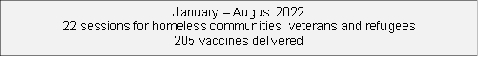

The work that was being carried out in the health hubs has now stopped due to the change in funding for vaccination services, and the termination of the mass vaccination service. Solent will continue for a time limited period to deliver a smaller outreach service, for 12 weeks, to continue to offer covid vaccinations in our under- represented communities (excluding MECC approach)

## Occupational Health

Within Solent, our Occupational Health and Wellbeing (OHW) service has continued to look at health inequalities and their specific health and wellbeing risks.  During the pandemic, Solent used the CARA (Covid-19 Age Risk Assessment) tool which focused on groups who were high risk to becoming seriously unwell from Covid-19 including colleagues from the BAME community and those with chronic, long term ill health who were shielding, including disability.  All Solent staff who scored high-risk during the CARA assessment were supported and signposted to receive immediate Covid-19 vaccination through their primary carer or the OHW service.

CARA assessments are still current in 2022 and during the onboarding process for new starters, the OHW service will assess not only fitness for duty and adjustments but also advise line managers to conduct appropriate risk assessments in the workplace, including CARA, New and Expectant Mothers, Manual Handling, Display Screen Equipment etc.

The OHW service continued to provide professional support to groups at high risk from Covid-19 through various communication channels from 2020 to the present time.  Welfare calls were available 5 days a week on a self-referral basis to the Health and Wellbeing Practitioners and these were well utilised across the Trust during the height of the pandemic, especially from high risk groups, who were naturally anxious about their personal level of risk.

The Solent OHW service is well supported at Executive and Board level and has Executive representation.  Relevant health themes, significant service feedback, new interventions and initiatives are presented routinely and directly to Executive level and support is provided consistently.

There is also representation of the OHW service at staff network groups and one of the Health and Wellbeing Practitioners attends all Chair meetings including LGBTQA+, BAME, multi-faith, disability, carers and 50+

In 2022, the OHW service carried out a gap analysis of health and wellbeing interventions at Solent based on the revised NHS E Health and Wellbeing Framework (Framework).  This Framework enables all NHS organisations to understand their own specific health and wellbeing needs of their diverse workforce and to introduce appropriate interventions where gaps are identified.  The revised Framework targets major factors which affect and could improve organisational health, namely management capabilities, job quality, social relationships at work, support for staff coping with health conditions or life stresses, and promotion of workplace health.

The Solent gap analysis has been completed and the Solent Health and Wellbeing Plan (Plan) is now under construction and is due to be launched on 10th October 2022 ‘World Mental Health Day’.  The Plan will improve focus on effective communication channels about health and wellbeing interventions and reaching marginalised groups including identifying what specific support is needed by these groups.  Measurement and reporting of the impact of the Plan’s interventions will help us build on current health and wellbeing successes, target health and wellbeing interventions more effectively, and demonstrate value for money.  Included in the communications for the Plan will be an enhanced recruitment, training programme and support for Health and Wellbeing Champions across the Trust, including focus on effective communication and improved engagement in hard to reach or marginalised groups.

The service maintains clear routes of access to services for all Solent staff and managers who experience illness or absence from work.  The management referral process exceeds 150 referrals per month in 2022 and supports staff and managers on the promotion of illness recovery, appropriate work adjustments to achieve this, tailoring returning to work during illness or with disability, signposting to targeted interventions e.g. mental health support, or Access to Work (UK Government scheme to support stay in work with physical, mental health condition or disability)  and specialist support with the overall aim of rehabilitating and resettling our staff back into good work and sustainable attendance in the workplace.

One group of staff that has received specific tailored support from the OHW service have been those individuals who have experienced Post Covid-19 Syndrome or ‘Long Covid’.  Many individuals who were infected with Covid-19, especially those infected prior to the roll out of the national vaccination programme in 2020, went on to develop often debilitating ‘Long Covid’ symptoms including respiratory, musculoskeletal, cardiac and psychological impact.  Solent staff who were affected were referred to the OHW and allocated a case manager (a Senior Occupational Health Advisor) who would act as their point of contact regarding their clinical recovery, support in the workplace and liaison with their line manager regarding rehabilitation back to work.  All cases of affected staff were discussed weekly by a specialist Multi-disciplinary team (MDT) within the OHW service and each case was supported individually by musculoskeletal and psychological specialists within the MDT based on their clinical presentation, job role and functionality at that time.

The majority of individuals had protracted symptoms of ‘Long Covid’ but many were successfully returned to work within a 2-3 month period.  Some individuals continued to experience severe and impactful functional problems for many months and they were supported by Solent NHS Trust to benefit from a financially supported extended phased return to work scheme, which enabled so many to return to work much sooner than if this financial support were not be in place (they would possibly have remained off sick from work for much longer).  Some individuals remain severely impacted in 2022 but continue to be supported by the MDT and their cases are reviewed each week to tailor specific rehabilitative support.

The MDT has worked in collaboration with Southampton and South-West Post Covid clinics (regional clinics) since January 2021.  Solent staff who have met specific criteria have been referred to this service for more targeted assessment and specialist medical intervention based on their clinical presentation.  These regional clinics form part of a research network in relation to Post Covid Syndrome and will share learning and jointly evaluate clinical outcomes.

## Building community confidence in the covid vaccine

In early 2022, the Community Engagement Team delivered a project addressing health inequalities by building confidence in the covid vaccine in our communities. Public health data across HIOW showed that take up of the vaccine was low amongst the following groups:

* Communities from low income and deprived areas
* People from minoritised communities
* Pregnant women

Whilst working with clinicians and community groups, the team held conversations with nearly 2000 people from these communities addressing concerns, questions and issues about the covid vaccine.

Feedback from these conversations included:

* Communities felt more confident to make decisions about the vaccines and some feedback that they made the decision to get vaccinated on the back of these conversations.
* Communities had more trust in health services and felt that they were not being forced to take the vaccine.

## Understanding the barriers faced by minoritised Communities from accessing Mental Health Services’.

In 2021, we carried out a project - ‘Understanding the barriers faced by minoritised Communities from accessing Mental Health Services’. A total of 108 members from ethnic minority communities shared their views with us. Key Findings from this project include:

* Lack of awareness of potential cultural areas of friction
* Visibility of the service
* Fear of stigmatisation
* Lack of awareness of available mental health support.
* Failure to self-identify mental health need
* Lack of representation in the mental health workforce

Recommendations:

* Talking Change Service to strengthen its relationship with local ethnic minority communities in Portsmouth
* Increased cultural awareness training for staff
* Increase visibility of the service
* Addressing lack of awareness of local mental health services amongst ethnic minority communities
* Addressing job security fears
* Self-identifying the need for mental health services

*For full details of the activities and strategy pertaining to community engagement see the Alongside Communities Strategy.*

## Chaplaincy Service

Chaplaincy focus continues to provide high standard of pastoral, spiritual care and religious care for all staff, our patients and carers.

**Chaplaincy focus has also centered on:**

* Monthly meetings with Southampton Council of Faiths continue.
* Providing staff wellbeing post covid/staff burnout/rising cost of living/affordable housing. working with Occupational Health Colleagues, Gemma Pegram, International Nurses, across the wards and Solent Sites. Part of the Schwartz steering group.
* Working as part of recruitment team for International Nurses, supporting them prior to arrival and in post. Part of the team facilitating the International Nurses’ Forum.
* Working with D&I team to promote human flourishing and belonging in the workplace, including promoting and supporting religious identity in the workplace and meeting the spiritual and faith needs of our patients. Chair of the Multi Faith Staff Network Group.
* Working and collaborating with other chaplains in Southern Health NHS Foundation trust, UHS, QAH in Portsmouth, IOWH and Hampshire Hospitals to provide a high standard chaplaincy service across the ICB.
* Working with other chaplains on the Wellbeing Hub for staff.
* Working in partnership with chaplains to provide a robust, evidence-based e-learning on spiritual care for staff to access across the ICB, some funding has been provided.
* Responding in a timely and professional manner to staff crises and providing support to Teams who are experiencing challenging circumstances.
* Conducting funerals for staff who have passed away, supporting their colleagues and families.
* Planning for a small team of volunteers to support chaplaincy provision.

# Appendices

## Diversity and Inclusion Action Plan



## WRES and WDES data Table

 

**Solent NHS Trust Workforce Ethnicity Breakdown**



## Patient Information data tables



## Hampshire County Council Equality and Diversity Profile 2011 Census



## EDS Summary Report





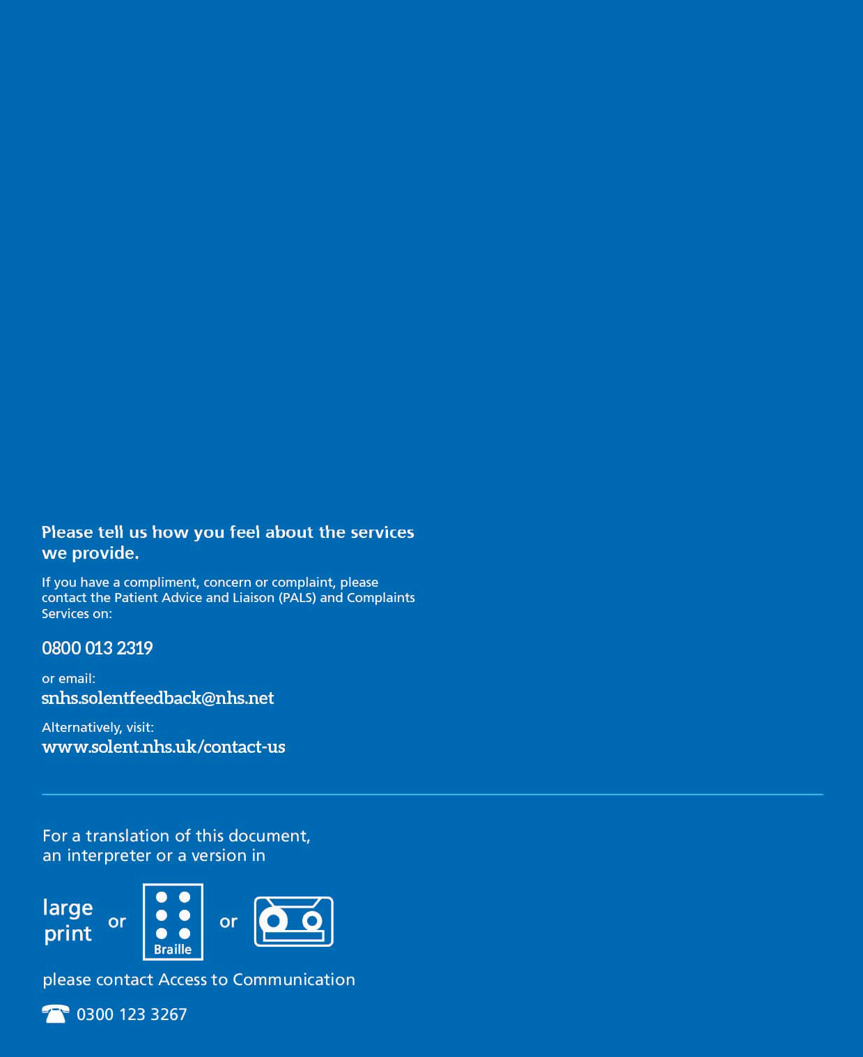

21